
Riverbank Nursery
Standards and Quality Report 2023-24

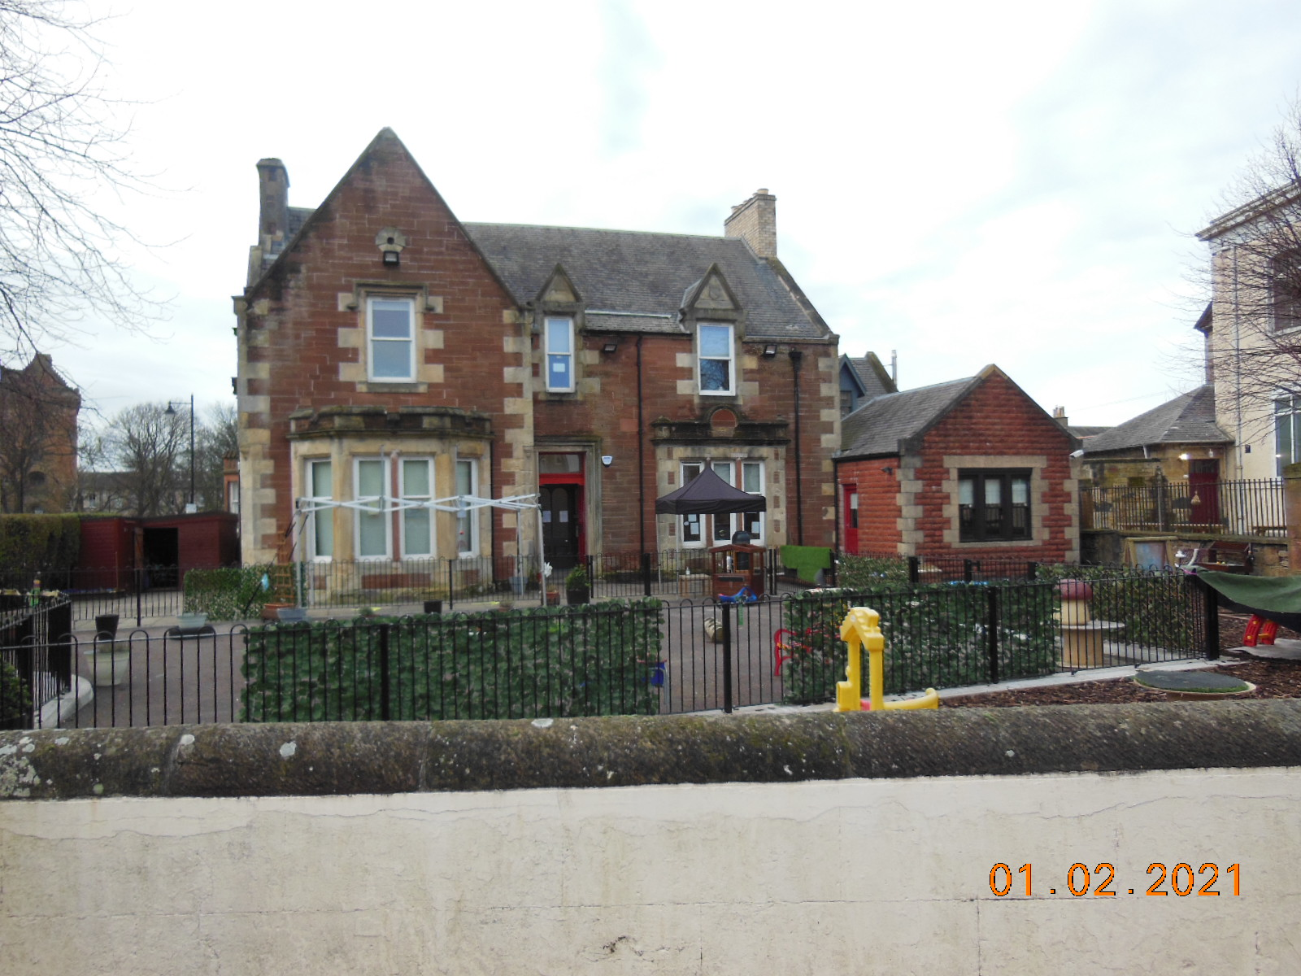
Introduction

Riverbank is a privately owned nursery caring for children aged 3 months to 10 years. We believe learning is individual to each child’s needs, abilities and interests and parents work collaboratively with staff in celebrating children’s achievements, strengths and in agreeing goals for learning and development. This supports children to realise their full potential and become successful learners, confident individuals, effective contributors, and responsible citizens.

Riverbank continues to maintain a strong family ethos, providing a home from home feel using the ‘Hygge’ approach. This is a Danish concept which promotes a nurturing and calm environment and slow pedagogy of being in the moment. This does not retract from intentional learning which is important in promoting and treating every experience as an opportunity to learn.

All staff are SSSC registered, ensuring a continuous cycle of reflection and review. The wellbeing of our staff has been integral to promoting a nursery wide approach to good mental health and wellbeing.

Values

As part of our improvement for 2024-25, we have begun a consultation on our vision, values and aims to state clearly what we stand for – this will include input from all involved in the life of the nursery. A shared vision which promotes children’s rights, fairness, and equality of opportunity. Our focus will be on developing the uniqueness of every child by providing a loving, caring ethos where children are valued and listened to.
We will ensure it continues to be ambitious and in line with local and national priorities. In addition to supporting children to be confident, healthy and happy, we aspire to put our values into practice.

In 2023-24 we reviewed our acronym to embed these values into everyday use by applying appropriate and meaningful language to support children’s understanding. Reflection has also assisted in consideration of how they link to the rights of the child, Getting it right for every child and Realising the ambition for parents to understand, while taking account of the on-going change and improvements of the nursery.
Following a competition on what our new logo should look like, the result was a child’s winning design. This is now on all correspondence, signpost and staff uniform. It relates to the importance of family, including being part of the Riverbank family.
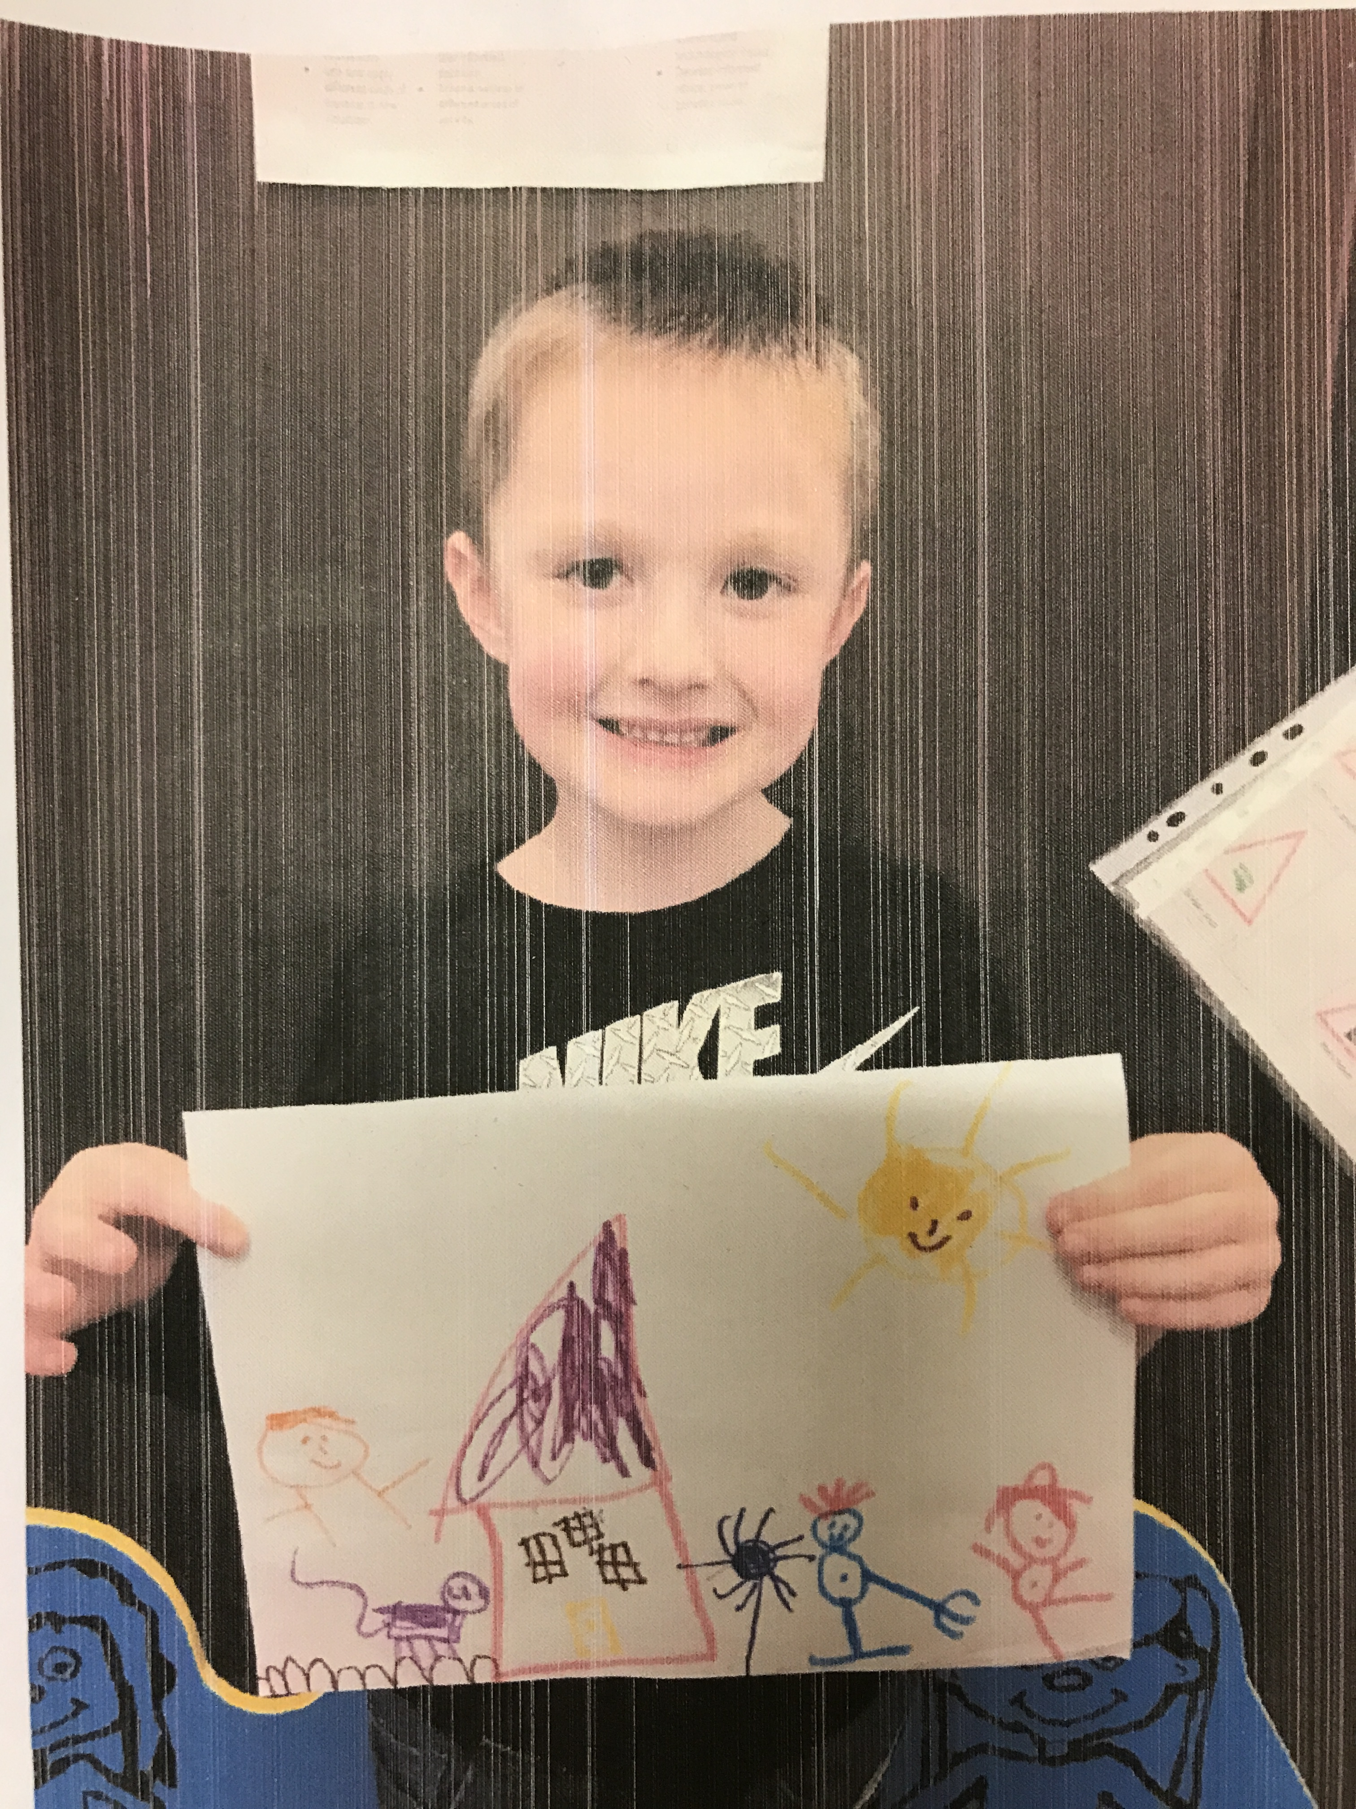
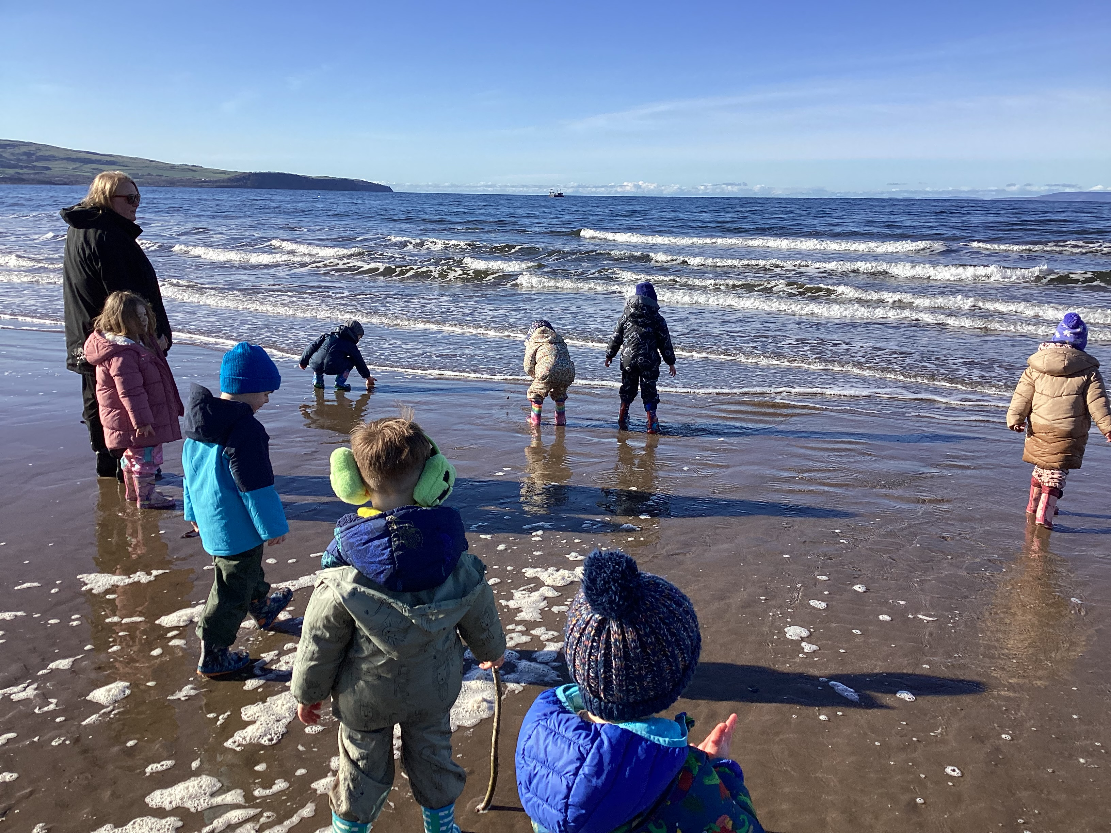
Respect
Inclusion
Value
Engagement
Responsibility
Being me
Active
Nurturing
Kind

Current Aims are to;

- Provide a safe, caring, nurturing, stimulating and secure environment to support resilience and wellbeing.
- Capture and enhance natural curiosity building on the child’s potential for learning to help create confident and enthusiastic learners.
- Provide a qualified motivated staff team committed to improving outcomes for children and families.
- Promote partnership working with parents, children, staff and other agencies to support and improve outcomes for children.

Context of the early years centre

Riverbank Nursery is situated in the heart of Ayr and has been established since 1989. It’s open from 8am until 6pm Monday to Friday, 50 weeks of the year. We are in partnership with the local authority, which means that although we are a private nursery, we can provide funded early learning and childcare on a part time, full year or term time basis for eligible children.

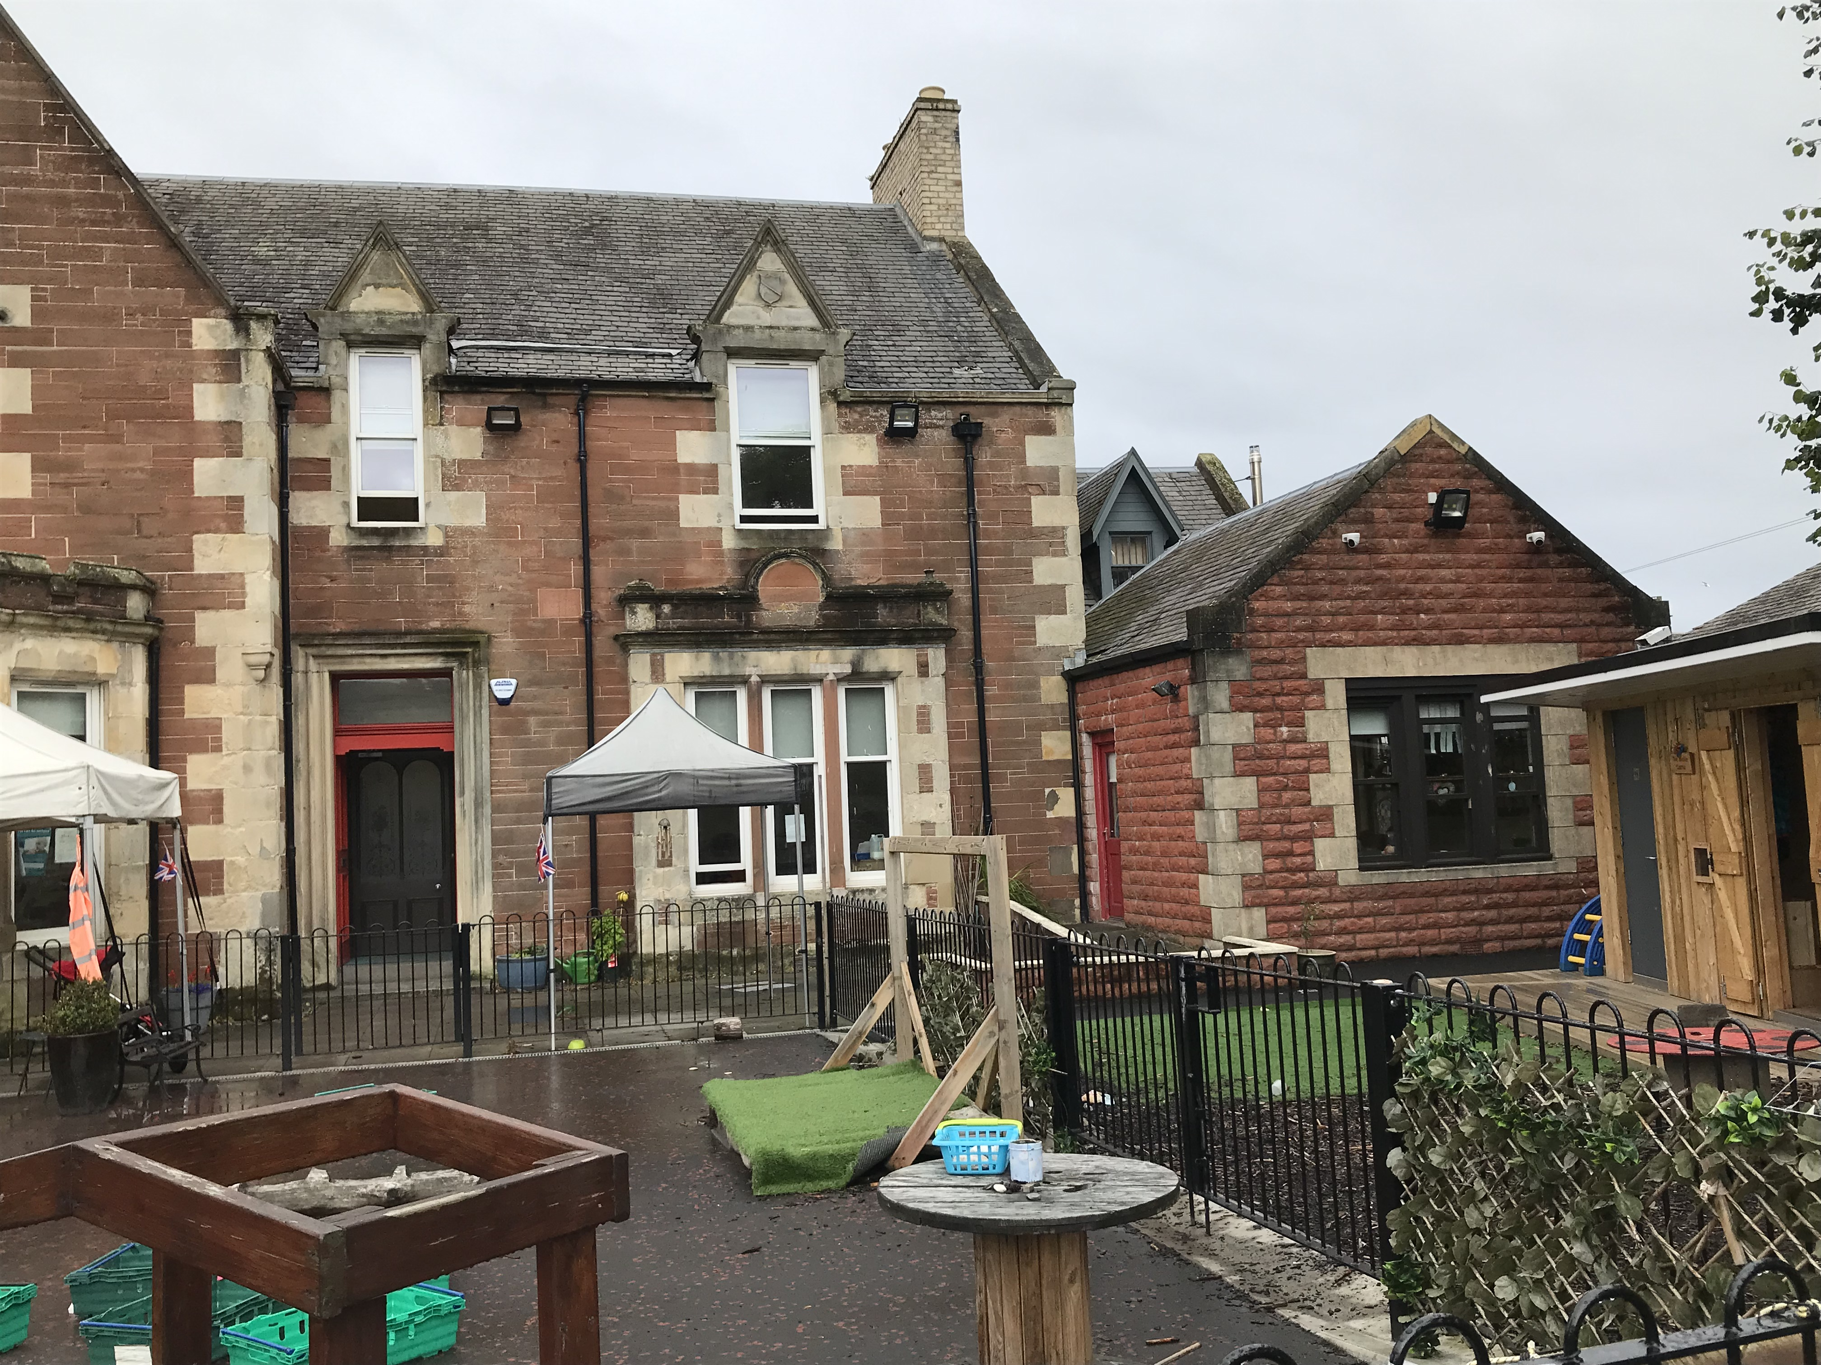
The Nursery building is set over two floors and comprises of eight spacious rooms, the ground floor accommodates our office, Bluebells, Buttercups, and Daises in addition to toilets and kitchen facilities. The upper floor plays host to our Juniors and Seniors along with children’s toilets and staffroom. Our outdoor space within the nursery grounds has been redeveloped as a large area for play and learning, promoting investigation and exploration through climbing, planting, cooking, digging, building, water and imaginative play. Our ‘Wellie castle’ provides a shelter and storage for outdoor rain suits and wellies, aptly named by the children. It also provides outdoor handwashing and toilet facilities. The indoor environment is also reviewed periodically to ensure it is responsive to the needs of the children, is stimulating, creative, exciting, and inspiring.

Out with the nursery, our children also utilise the grounds of St John’s Tower and the Fort Tennis Courts which are both only a few minutes’ walk from the nursery. As we have a central location, we benefit from walks to explore our local environment including the beach, river, train station and many more on a regular basis. Our ‘Teach on the beach’ programme supported our eco schools plan in learning about ocean pollution and climate change. We aim to continue to develop these experiences further in 2024-25.

As we are based in a central location for working parents our children are from all Scottish Index of Multiple Deprivation (SIMD) areas. Many children attending Riverbank are from parents in employment, resulting in part time placements with a few attending full time. The percentage of SIMD deciles are detailed as follows;

22.3% of our children are from deciles 1-3 | 39.5% of children are from decile 4-7 | 38.2% are in decile 8-10

We foster close links with our associated primary schools to ensure that children are confident in making the transition from nursery to primary education. Local schools have sent representative teachers to Riverbank to meet the children and discuss with keyworkers transition arrangements within their school.
.
We strive to further enhance achievement, attainment and consistently as we improve the learning experiences provided to create independent, confident learners. Our tracking and assessment processes assists in identifying children’s progress and any gaps in learning. We moderate the data and evidence gathered to discuss milestones and targets with parents. We aim to develop this further by involving the child in their own assessment through their learning journals.

We need to continue to reflect on ways to secure the reliability and accuracy of judgements made by different practitioners through moderation activities.

The following information was obtained in May 2024 and is recognised as the percentage of achieving 8 or more milestones as detailed below;-
 | 2020/21 | 2021/22 | 2022-23 | 2023-24
Health and wellbeing | 75% | 95% | 93% | 100%
Communication and language | 60% | 70% | 87% | 71%
Mathematics and numeracy | 65% | 60% | 88% | 79%

This session our attainment figures demonstrates that all children have made good progress in Health and wellbeing. Communication and Language skills show children can talk clearly, follow instructions and regularly chose to ‘read’ books. Areas to improve include recognition of letter symbols, syllables and words starting with the same sounds. Since the introduction of a construction area there are some areas that children have made good progress in counting, matching and sorting and copying patterns. Areas to improve include recognising how many without having to count, using positional language and understanding simple graphs and charts.

During quality assurance discussions we agreed the following grades using the six point scale for 2023-24;

Quality indicator | Category | Theme | Current Grade | Improvement priorities for 2024-25
1.3 | Leadership and management | Leadership of change | Good | Developing a shared vision, values and aims
2.3 | Learning provision | Learning, Teaching and assessment | Good | Quality of interaction  Learning and engagement
3.1 / 3.2 | Successes and achievement | Securing children’s progress | Good | Progress in communication, early language, and mathematics. Children’s progress over time

A new nursery team have worked well together, and a number of important changes have been made relating to child consultation and communication, impacting on confidence and wellbeing, which has received positive feedback from parents. While we have important strengths within all areas of our work, we recognise areas for improvement particularly within our strategic work and so we are continuing to grade ourselves as: Satisfactory with some good points.

What key outcomes have we achieved?

As we await our accreditation through the ‘hygge’ approach we foster warm, nurturing relationships to offer a secure, safe, stimulating and above all a happy, home from home environment where kindness and love is central in all interactions.

Our ‘Teach on the Beach’ programme recognises not only the environment as the third teacher but as research explains nature as being the invisible curriculum. We therefore nurture the children’s natural inquisitiveness and inherent tendencies to learn by exploring the world around them as we investigate and embed good practice in modelling this for children.
As part of our Eco schools programme, we have found that direct, consistent exposure to sustainable concepts through teach on the beach, we have built environmental understanding. By developing our focus on how nature pedagogy interacts and influences wellbeing, not only in our children but also our staff and wider community, we continue to respect and support the rights of all, while recognising the needs of our planet. Ayrshire college NC students supported our first year of ‘Teach on the Beach’ on a weekly basis, joining us in learning and discovering about pollution and Ocean life. Our Beach clean-up was also supported by SAC who provided litter pickers and bags.

Development of the rooms has provided clear opportunities to support all areas. Three staff have now attended literacy training which is reflected in their professional dialogue and practice and is beginning to impact on children’s outcomes in literacy learning. Further training opportunities in nurturing mathematics and language through outdoor play has been scheduled for the new term for more staff.

Play on pedals training resulted in many children over the summer months, gaining new skills and confidence in wearing safety equipment, using a balance bike or advancing to the use of pedals to ride their own bikes.

Children are involved in enterprising events including raising money for charities and taking part in community initiatives, for example, Riverbank won third place in South Ayrshire ‘Beat the Street’ attending the prize ceremony with the child and parents who were at the top of our leaderboard. We also raised £201.95 for McMillan Trust.

Priority 1 Use digital technology to support learning, teaching and assessment
NIF Priority:- Closing the attainment gap between the most and least disadvantage children | Links to HGIOELC QI:-  1.3 Leadership of change  3.2 Securing childrens progress  3.3 Developing creativity and skills for life and learning | Links to CI Quality Framework QI:-  1.3 Play and learning  3.1 Quality assurance and improvement  3.2 Leadership of play and learning

Progress and Impact
Due to a number of barriers outlined in our pros and cons research into online journals, we have postponed the consideration of these until later next year until staff have been trained appropriately and all safety measures introduced. We have reflected on our assessment approaches and set up a more robust system to monitor progress and successful learning in paper format for the individual child. We have consulted with parents on the need for access to photographs and communication methods, including how this can be managed effectively and appropriately without deterring from time spent with their child. We are considering additional ways to exchange and gather information and organise care plan meetings in a timely manner to enhance partnership with parents.

Paying attention to how children sort objects, asking them to sort in different ways, and prompting them to describe and talk about their learning began an inquiry about technology and how words can be recorded in different ways.
We introduced how to use a QR code for children to record and listen to their own voice. This was exciting as they learned about coding, recording and listening to what others said, without being able to respond like a telephone.

Imaginative role play has introduced technology through the use of tools, learning how things work, and how they are used in real life situations. The children can talk about the use of ICT at home, about electricity and power, and have also learned about safety in the home through the Fireman Sam workbook, where all received a certificate of completion. This also provided an opportunity to learn about other aspects of safety, including fire safety and prevention. The children can talk about dangers from electricity, fire, water, the use of cleaning materials, stranger danger and road safety. Technology has a huge impact in todays world and through the above concepts, children know about the importance of staying safe, including in the use of ipads and phones. They know what do in the event of an emergency and who to talk to if they are worried or scared about something.

Children have utilised the opportunity to explore and take apart different technologies to see how they work; an alarm clock, calculator, camera, mobile phone and an old computer. They used screwdrivers, pliers, magnify glass to look at the different components. Some children have become very confident in using the Beebot, recharable cars and torches to experience the wonder of technology. They have become more independent in performing web searches, using smart devices such as, Siri, and Amazon Alexa, to ask questions or listen to music and songs. Almost all children are beginning to understand how systems and technology is being used in the world around them. They can talk about how family can order food using the computer or phone. Calendars, timetables, cooking times, including Alexa timers can provide information and visual cues about routines etc.
Next steps;
- Continue to monitor the use of and understanding of digital technology
- Develop the ‘Family app’ for gathering further data on children’s progress and development

Priority 2 Reflect on our pedagogy the curriculum we offer to support literacy, and numeracy (indoors and outdoors)
NIF Priority:-  Improvements in attainment particularly in literacy and numeracy |  | Links to HGIOELC QI:-  2.2 Curriiculum  2.3 learning, teaching and assessment  3.1 Ensuring wellbeing, equality and inclusion | Links to CI Quality Framework  1.1 Nurturing care and support  1.3 Play and learning.
Although we regularly read stories with children, we chose to celebrate World Book Day at the beach providing them with an understanding that books are important regardless of place. This supported children’s imagination and creativity to connect with characters who build sandcastles, collect seashells, and encounter friendly sea creatures.

Children also experienced story telling in another different environment by different people and contexts, showing patience and concentration as they took part in an interactive performance of ‘Trouble in Toytown’. On return to nursery, they could recollect what happened in the story, the sequence of events including what happened at the end, and some children could re-enact different scenes for others to observe.

Children have many opportunities to be exposed to literacy and numeracy concepts in imaginative play. Setting up a range of different imaginative play and small world experiences has been one of the most effective ways we have used to help children recognise signs, symbols and practice their thinking skills and language at the same time.

Through Phonological awareness training, staff have improved their understanding of the various skills gained as children had fun with language, they loved making silly rhyming sounds and can identify alliteration. They learned about syllables in songs, names and words and used jokes and action games to consolidate their learning in these. Our favourite joke from Toby was ‘Where does a fish keep its money? – In the Riverbank!

Through focused learning in Numeracy, some children designed and built complex buildings with a variety of blocks and materials, they developed their problem solving skills outdoors using large blocks, tyres, reels, planks and guttering, and are beginning to recognise spatial awareness, by climbing, filling and emptying water containers, transporting bark and plants in wheelbarrows and much more.
Next Steps
- Further training will continue to be developed to ensure consistency for some staff to reflect, review and understand the milestones to support effective planning and assessment
- There is need to focus more on pace and challenge during tracking meetings to meet the needs of all learners effectively.
- To continue to use our literacy trackers to identify children’s strengths, where support is required and areas where children require more challenge
- Identify more clearly when children are making progress in numeracy

Priority 3 Reflect on our pedagogy and the curriculum we offer to support health and wellbeing
NIF Priority:-  Improvement in childrens Health and wellbeing | Links to HGIOELC QI:-  2.2 Curriiculum  3.1 Ensuring wellbeing, equality and inclusion  2.4 Personalised support |  |  | Links to CI Quality Framework  1.1 Nurturing care and support  1.3 Play and learning  3.2 Leadership of play and learning
Progress and Impact
As we await our Hygge accreditation, we continue to focus on slow pedagogy and being in the moment with children. By adopting a nurturing approach to practice and a listening pedagogy, we are able to tune into what children need and deserve and help them to understand their thinking. We have tried to look at the environment through the eyes of the child and provided opportunities for them to create cosy corners using cushions and materials, and to develop home areas which reflect real home life. It has been a long journey which is progressive as we embed what we have learned, build new connections in the community and used nature outdoors as a tool to support wellbeing.

Visits to our local care home has helped children see an older generation with a variety of disabilities, it has helped them to reflect on similarities and differences, feel more empathy towards others, and to build relationships which they would not generally have made. Children learn by watching and talking to people, having positive interactions, listening and learning about manners and turn taking during conversation. Following a visit to Atlantic view care home, singing and dancing, and cake decorating at Riverbank both children and older adults felt valued and important, showing increased self-confidence and motivation to continue these visits. It’s wonderful to watch them engage with each other, learning together in such a positive and caring way.

All staff have completed Child protection / Safeguarding training updates which also included the use of SIMOA bitesize training to ensure the safety of children at all times.
Next Steps

- Develop the use of SIMOA and wellbeing buddies
- Continue to improve family relationships through Stay and Play sessions, trips in the local and wider community
- To continue to keep nurture and Health and Wellbeing at the heart of everything we do as this will support closing the attainment gap.
Priority 4 Continue to build SE within the team on a regular basis to lead improvements for all.
NIF Priority: Closing the attainment gap between the most and least disadvantage children | Links to HGIOELC QI:-  - Self-evaluation for self-improvement  1.2 Leadership of change  1.5 Management of resources to promote equity |  |  | Links to CI Quality Framework  2.2 Children experience high quality facilities.  3.3 Leadership and management of staff and resources  4.1 Staff skills and knowledge
Progress and Impact
Our approach to quality assurance is beginning to reflect a team approach while discussing our progress and areas to develop. All Senior staff have become more familiar with the reflective questions from ‘How good is our early learning and childcare’ and the Quality framework, as key features in influencing our practice for the benefit of children’s outcomes. However, we aim to continue to develop staff leadership roles to have confidence in their capacity to support children to reach their full potential.
All staff are aware of the changes in SSSC codes, the updated registration information, and the training opportunities available. This will be further developed as staff training will be priority for improving outcomes for children.

Observation of staff using open questions has identified many are at the early stages, most are still developing their questioning skills to improve engagement and learning, many are reflecting on how to scaffold children’s learning effectively as we recognise the need to continue to further develop this skill. Consultation and discussion on continuous provision and meeting the needs of individual children is on-going. Using floorbooks as a means of evaluating intentional plans and responsive learning with children, has increased some staff confidence in consulting with children.

Following training on monitoring and self evaluation, we have introduced a more reliable and effective system. During a review we used ‘Realising the Ambition – Being Me’ (RtA) and How good is our early learning and childcare (HGIOELC) to reflect on our environment, resources and quality of practice. Exploring this document in more depth has highlighted areas for continued staff development, the need to embed consistent critical reflection and to develop more regular formal dialogue. We have reviewed our assessment and data collection processes to link with RtA and will continue to monitor this.

Next Steps
- Increase reference to children’s rights in planning and displays throughout the nursery
- Build self-evaluation into every staff meeting so that staff become more confident in using evaluative language and thinking about what is working well and what we can improve on.

Evaluation Summary

Quality Indicator | Self Evaluation  (Please add 3 or 4 evaluative statements linked to the themes)
1.3  Leadership of change  Developing a shared vision, values and aims relevant to the ELC and its community  Strategic planning for continuous improvement  Implementing improvement and change | Our vision, values and aims were reflected on by considering how they link to the Rights of the child, Getting it right for every child and Realising the ambition and if they were easily understood by all. However, due to the number of new children, and families, new staff and younger children progressing through different stages, it has been agreed to reflect on these in more detail to ensure relevance to what we currently represent and aim.  Being able to recognise things that we do well and identify areas that may need improvement is a skill that builds with time and practice. As staff become more involved in self-evaluation through their leadership tasks they are beginning to probe deeper to consider what impact it has on children. They are also considering what kind of evidence can be used to support our improvements.  Training on effective communication helped staff to consider ‘what they want to continue to do, what they need to stop doing and what they need to improve on.’ This is supporting reflective practice during appraisals and self evaluation. Staff feel communication between colleagues has improved.  Connections between education and the world of work resulted in Riverbank being involved in presenting at a careers fair. Our children designed and made a poster and helped agree what resources to take along to show young people what a job in nursery is like. The children were asked what kind of person should work in a nursery. Many had thoughts on this, including kind, quiet, happy and fun, while others thought appearance was important, including long hair. Parental consent was agreed to provide photographs of children’s engagement in experiences, linking these to curricular areas. This was then followed up in Riverbank being involved in ‘mock interviews’ with young people interested in a career in childcare. Further collaboration with school and college students will continue in 2024-25.  Children have had various opportunities to develop their awareness of the wider community and the world of work.  Next steps  Continue to work collaboratively with local schools and colleges to talk to young people, and students about early years, the profession and career opportunities
2.3 Learning, Teaching and Assessment  Learning and engagement  Quality of interactions  Effective use of assessment  Planning, tracking and monitoring | All practitioners recognise each child’s needs and value them as an individual. Most staff have a clear understanding and are confident of their role in the planning process. They are beginning to understand the contexts within the Curriculum for excellence and will attend further training to support this.  Care Plans, Learning Journals, observations and professional dialogue are used to record, monitor and track the achievements and progress of every child. Times set aside for moderation and professional dialogue provided an opportunity to collectively discuss assessment and come to a shared understanding of the children’s progress. Samples of observations and assessments including next steps are reviewed monthly and discussed with individual staff. Support for new staff will continue in this.  Understanding the impact of continuous provision has been challenging for some staff, however providing opportunities for children to foster independence, creativity and active participation in learning, literacy and numeracy skills, has provided time for staff to observe, support, challenge and teach. It also allowed time for consolidation. Care plan / learning journal targets for children are carefully monitored and shared regularly with parents/carers.  Parents comments in QI 2.3 include; ‘What a privilege to have my child spent her nursery years at such a special place.’ My child has enjoyed every minute of his time with you and had so many fantastic experiences thanks to your dedication and devotion.’ ‘We hope you never underestimate the positive influence you have on all these little children. They are so lucky to have you.’  There are some examples of good practice in using outdoor learning to enhance the curriculum, however, there remains a need to develop consistency here.
3.1 Ensuring wellbeing, equity and inclusion  Wellbeing  Fulfilment of statutory duties  Inclusion and equality | Staff have begun to embrace both nurture and the UNCRC to support children in developing resilience to cope with change, this includes children moving rooms within the nursery and those starting school. We consulted with parents and provided reassurance and information regarding any changes involving their child and used flexible routines to ease the process of adjustment for both children and their families. Staff know the children well and can recognise and respond to any changes in confidence, and/or behaviour, they work together with parents to provide assistance where required.  Our policies and procedures for child protection and safeguarding has been updated this year following training and to reflect current legislation including UNCRC and GIRFEC. All staff have a good understanding of their responsibilities in relation to whistleblowing, child protection and safeguarding and legislation linked to wellbeing, inclusion and equality.  All staff have complete bite size training on SIMOA guidance. SIMOA elephants are regularly used and referred to with children to reinforce the message to safeguard, protect and support children’s wellbeing. When planning for change children will confidently participate throughout each stage to influence decisions. This includes organising events and celebrations, changing of resources, development of rooms and in planning and evaluation.
3.2 Securing children’s progress  Progress in communication, early language, mathematics, health and wellbeing  Children’s progress over time  Overall quality of children’s achievement  Ensuring equity for all children | We have been working on how to complete effective observations of children’s progress and learning without underestimating and deterring from the importance of interaction. We introduced a new format for observations to ensure they were relevant, proportionate and had meaning. This reflects how we intend to use the information we have just observed to further extend or support the child’s thinking and learning. Some staff are beginning to understand this and get the balance right between interacting with children and completing paperwork. We are currently modelling support for others to gain confidence in this.  Most children are good communicators and enjoy talking and sharing ideas, some of these ideas are visible in drawings and making their own story books. Our assessment processes include individual tracking, floor books, mind mapping, and evaluations to consult with children and inform planning. Their contributions and achievements are recorded, valued and displayed in a variety of ways.  The opportunities for learning through Teach on the beach has supported environmental sustainability and respect of the environment. All weather clothing provided, ensures every child has access to the outdoors.  Following training on enabling environments, leading pedagogical change and our on-going Hygge developments, we ensure all areas create opportunities for language and communication, imagination, collaboration, problem solving and movement. Together time conversations have supported children to express themselves, listen to others and expand vocabulary. Our introduction of cosy spaces in all areas provide opportunities for children to sit and think, or talk quietly together, improving self regulation skills.

What are the key priorities for improvement in 2024/25

Our Improvement Plan takes account of local priorities alongside those in the National Improvement Framework (NIF).

- Vision, values and aims
- Upskills staff team - Quality of experience and interaction, learning and engagement
- Progress in communication, early language, mathematics and wellbeing
- Children’s progress over time

What is the capacity for improvement?

As our staffing levels continue to settle, we begin to consider the quality of our provision, our strengths and areas to improve. We are strongly committed to continuous improvement in driving the nursery forward and developing staff practice and skills to improve outcomes for children.

We will use information from a variety of sources to ensure that decisions about improvements are based on robust evidence. To support this, we will continue to work with staff, families, other professionals and our partners in the local authority and community to ‘get it right’ for every child. This will enable us to identify key strengths within our nursery and areas of improvement.

Feedback from families, staff and children and direct observations of practice provide a triangulation of evidence to inform this report and have been used to develop the improvement cycle.

