
Riverbank Nursery
2 Citadel Place
Ayr
KA7 1JN

IMPROVEMENT PLAN: 2025-2026
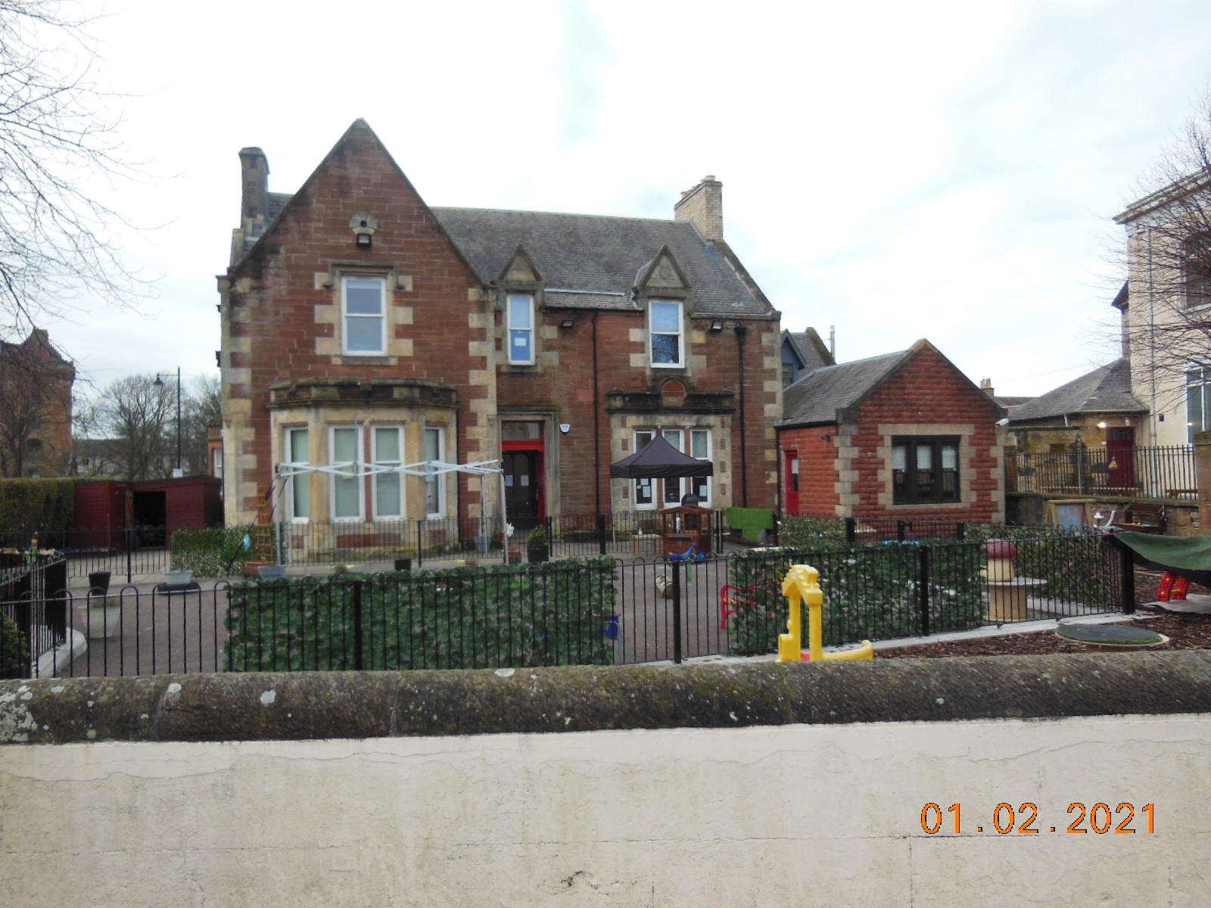


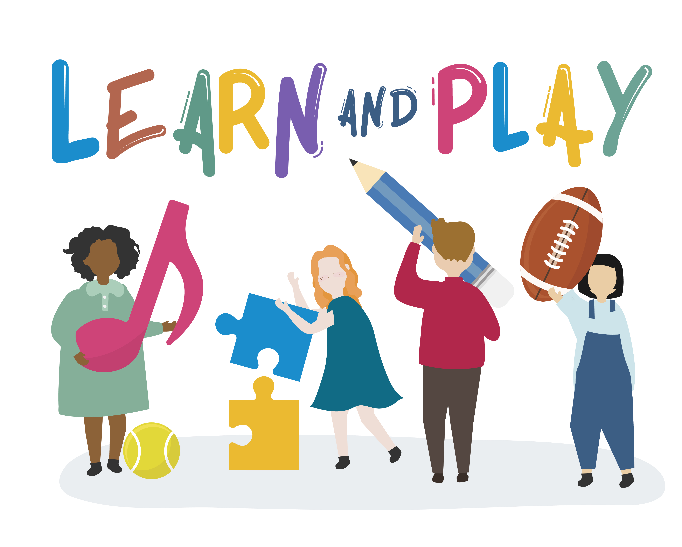

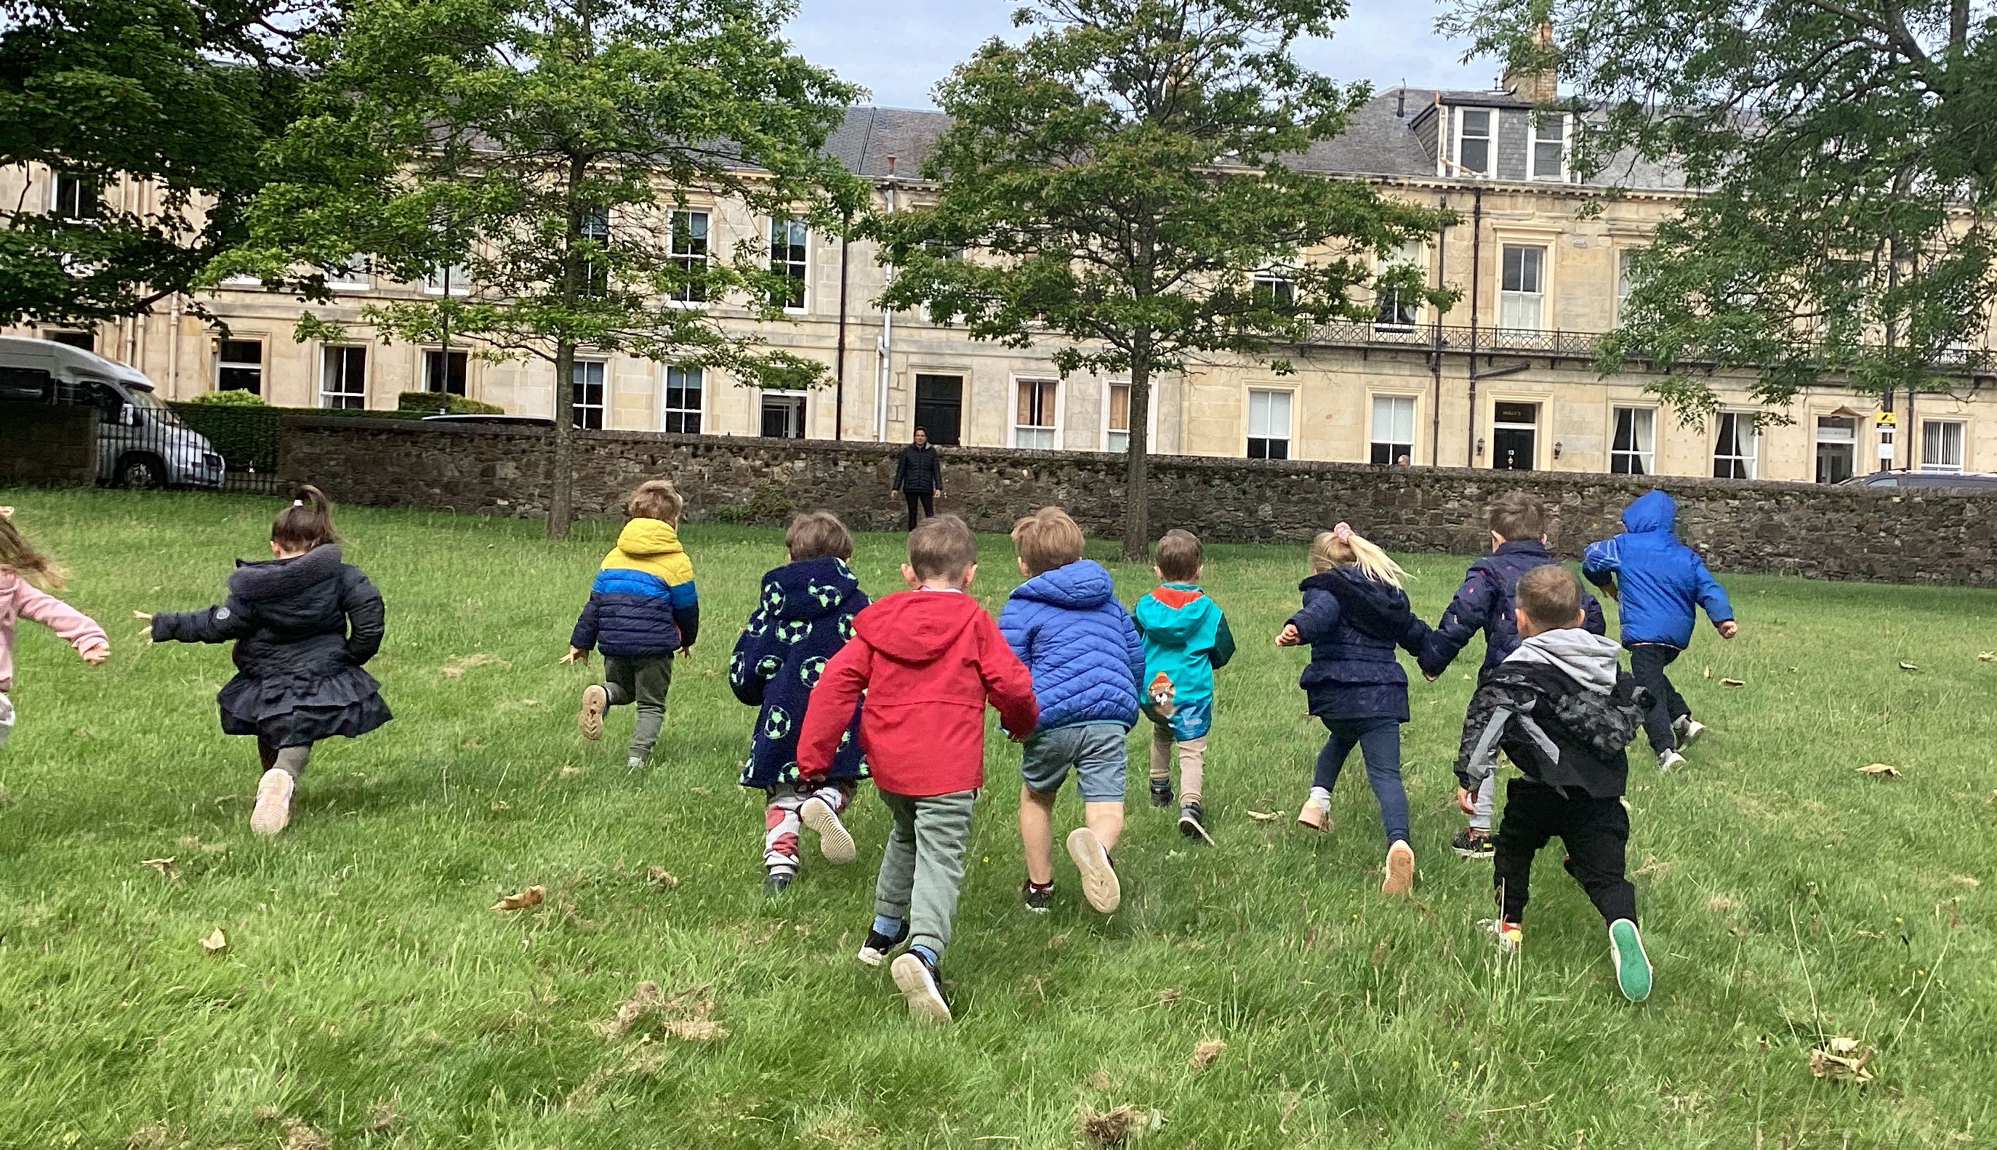


- Spaces and Places
- Live, Work, Learn
- Civic and Community Pride

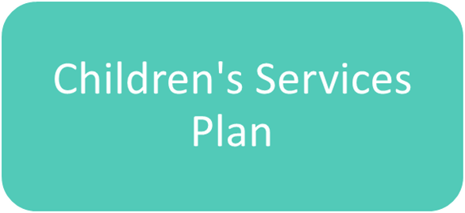
- The Promise: Our commitment to Keeping the Promise
- Family: Promoting whole family wellbeing
- Included: Early help for children with diagnosed or undiagnosed additional support needs
- Healthy: Improving physical and mental health for children and young people
- Voice: Involving children and young people in local decision making
- People: Collaborative learning and reflection opportunities for the workforce


- Engaged and Included
- Outstanding learning, teaching and assessment
- Developing our curriculum
- Self Improving Service

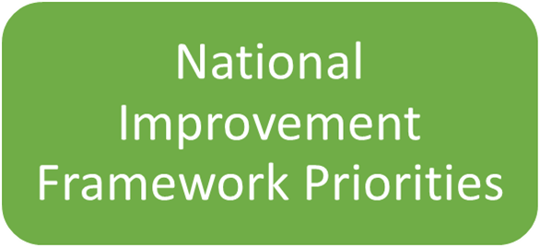
- Placing the human rights of every child and young person at the centre of education
- Improvement in children and young people's health and wellbeing
- Closing the attainment gap between the most and least disadvantaged children and young people
- Improvement in employability skills and sustained positive school leaver destinations for all young people
- Improvement in attainment, particularly in literacy and numeracy

What is our capacity for continuous Improvement 2025-26
With staffing levels stabilised, efforts have been redirected towards systematically evaluating the quality of provision by reviewing both strengths and areas for improvement. A variety of data sources are used to guide these developments, with input from colleagues, families, professionals, and local authorities to support effective outcomes for children. The team maintains consistent standards of care and education, accompanied by ongoing professional development.

To enhance our service delivery, we reviewed strategies for deepening our understanding of the new Quality Framework, with a particular emphasis on integrating children's rights. Additionally, we identified opportunities to provide further training to advance staff skills and knowledge.

The nursery will maintain an environment that supports inclusion. The learning approach recognises variations in children's experiences, interests, and backgrounds and aims to provide equal opportunities for all.

Our Standards and Quality Report and Improvement plan will be published on our website, promoted within and displayed as part of our journey to improvement.

Vision, values and aims reviewed in consultation with children, parents and practitioners

Our vision is to be a positive influence upon every child’s life by encouraging them to become all they can be, to build life skills and thrive. We do this by ensuring a warm, welcoming and nurturing environment designed to foster children’s natural curiosity and creativity.

Our belief is that, given the security of a safe, caring and loving play space, each child’s confidence will bloom, enabling them to discover their individuality and to develop skills at their own pace in a culture of mutual respect and kindness.

Our broad and varied learning experiences will offer children the freedom to explore and investigate through play, to express ideas, be active, question thinking, problem solve, risk-assess and have a sense of pride in their achievements.

Vision - Making memories by inspiring challenge and adventure!
As part of our improvement for 2024-25, we had begun a consultation on our vision, values and aims to state clearly what we stand for, this included input from all involved in the life of the nursery. A shared vision which promotes children’s rights, fairness, and equality of opportunity. Our focus will be on developing the uniqueness of every child by providing a loving, caring ethos where children are valued and listened to.
We will ensure it continues to be ambitious and in line with local and national priorities. In addition to supporting children to be confident, healthy and happy, we aspire to put our values into practice daily.

Values

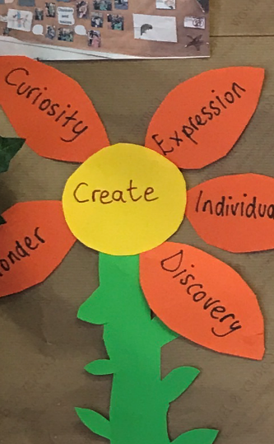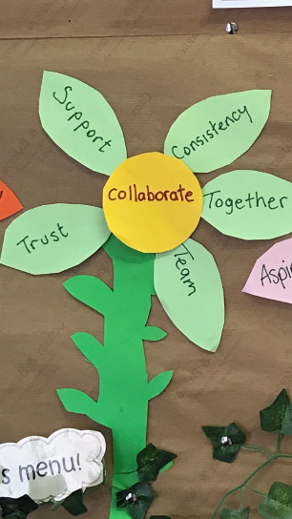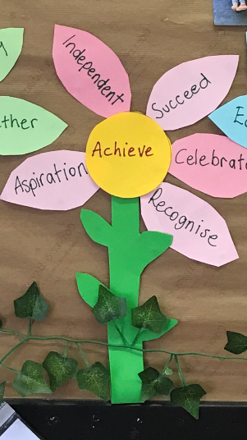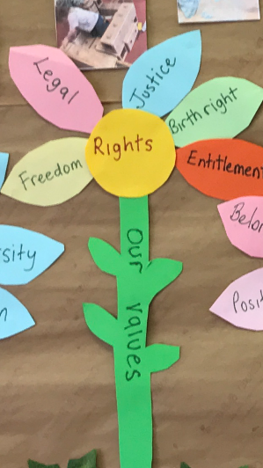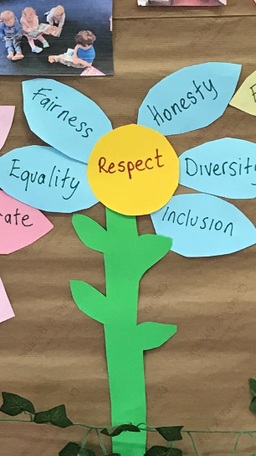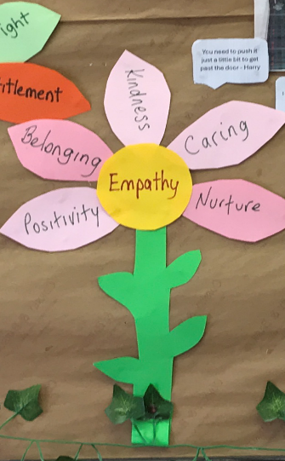

CREATE COLLABORATE ACHIEVE RIGHTS RESPECT EMPATHY

Aims

- To ensure that all individuals, regardless of their background, ability or differences, are valued and treated equally. Thus, creating an environment that welcomes and embraces diversity, where everyone feels valued, respected, and supported.
- To capture and enhance natural curiosity, building on the child’s potential for learning to nurture confident, capable and enthusiastic learners.
- To promote a culture of continuous professional development, creating an environment where learning is valued and supported every day.
- To promote effective partnership working with parents, children, staff and other agencies to support and improve outcomes for children.

Priority 1:-. Further develop rights based pedagogy to promote equality, equity and inclusion  Children’s services; Our commitment to Keeping the Promise  NIF Priority: Placing the human rights of every child and young person at the centre of education |  |  | Links to Quality Improvement Framework  Children are supported to achieve – Wellbeing, inclusion and equality  Children’s play and learning – Learning, teaching and assessment
What Outcomes Do We Want To Achieve? | How Will We Achieve This?  (Intervention Strategies) | Lead Person | Start and Finish Dates | How Will We Measure Impact On Children and Young People?  (Include Where Possible Current Measure and Target)
Begin to identify how the UNCRC rights are linked to all we do in Nursery – curriculum, planning, learning, and familiarise with these | - Promote and realise children’s rights and the values of respect, dignity and non-discrimination by embedding the UNCRC in all practices.  - Continue to offer CLPL to upskill staff and develop use of strategies to support all learners. | Nicole and Louise | Sep 25 - Dec | - Children are made aware of their rights and how these rights are applied to support a safe and orderly environment in the nursery as part of the children’s individual leadership activities. Evidenced in their learning journal through, their voice, photos and observations.  - Applying the Care Inspectorate Quality Framework challenge questions to support the integration of Children’s Rights in the nursery.  - The displays showcase both children's perspectives and evidence of their learning.  - Staff training and evaluation on UNCRC to review the approach to promoting children’s rights and The Promise framework
All children have equal opportunities and have their individual needs recognised, documented and met | - Use the national practice model/my world triangle to help identify the factors associated with speech, language and communication outcomes,  - Support parents to build speech, language and communication development at home  - The children to have access to an environment that is inclusive and literacy rich  - transition for children who attend more than one setting | Nicole Louise  Bethany | Oct 25- Feb 26 | - Evaluation of completed targeted intervention planning and assessment data has been conducted.  - Early speech, language, and communication is encouraged through home links, lending library, Bookbug sessions, and Stay and Play activities.  - The children's voices, interests, and contributions are visibly represented throughout the nursery environment, including initiatives such as "word/letter of the month," story sacks, sequencing activities, and voting for favourite books.  - Use of stories and block play for transitions, along with individual visual cues.  - Training staff to enhance their understanding of attachment and trauma issues.
To improve the quality of staff / child interactions to support or extend children’s learning. | - All staff to be aware of their role in extending opportunities for children to lead their own learning and share their interests  - Staff to develop an understanding of how to skilfully interact, knowing the difference between interacting/ interfering and how to extend the learning | Candace  Nicole  Laura | Aug 25- Oct 25 | - Conduct room monitoring on an alternate monthly basis and perform critical friend observations to systematically document staff approaches and interactions.  - Differentiating teaching and learning, facilitating meaningful discussions, and supporting ongoing collaborative thinking.  - A questionnaire designed to encourage reflection on existing practices, knowledge, and skill sets
Priority 2 Reflect on the impact of ‘spaces, experiences and interactions in extending children’s learning indoors and outside  Educ services; Engaged and included  NIF Priority; Closing the attainment gap between the most and least disadvantaged children and young people |  |  | Links to Quality Improvement Framework  Children thrive and develop in quality spaces – they influence and affect change  Leadership for continuous improvement – Leadership and professional learning -
 | How Will We Achieve This?  (Intervention Strategies) | Lead Person | Start and Finish Dates |  | How Will We Measure Impact On Children and Young People?  (Include Where Possible Current Measure and Target)
All children receive consistently well  planned learning experiences and opportunities to  provide appropriate challenge,  differentiation and pace in numeracy and  mathematics. | - Children will experience appropriate numerical learning activities indoors and outdoors  - Provide open-ended resources,  - Provide opportunities for discovery and connection with nature.  - Use open ended enquiry, testing predictions and developing the understanding of STEM concepts  - Create spaces that are responsive to the interests and abilities of each child | Bethany  Candace  Laura  Nicole | Nov 25-May 26 |  | - Resource audits complete  - Aim to increase attainment in maths and numeracy milestone data from "most children achieved" to "almost all children achieved."  - The Leuven involvement scale will be applied at regular intervals to monitor progress.  - The use of practitioner open-ended questions will be implemented to encourage curiosity, inquiry, and exploration through 'Big Questions.'  - Assessment of staff training in outdoor learning, STEM, mathematics, and numeracy as components of ongoing professional development  - Planning evaluations will show breadth, depth, challenge and enjoyment
Encourage children to think innovatively, empowering them to make a positive impact on the world. | - Provide opportunities for children to work on projects, based on their interests, life skills and in collaboration with the community.  - Utilise partnership working within the community  - Work towards achieving ECO Green Flag status  - Continue the Eco floorbook to showcase the journey to sustainability and becoming an eco-friendly nursery | Lauren Nicole  Candace | Oct 25- June 26 |  | - Assessment of collaboration among peers  - Documentation of all broader achievements accomplished outside the home – Achievement Wall  - Children demonstrate curiosity and a motivation to explore, as indicated by observed and documented levels of involvement and engagement.  - The environment and space audits have been conducted using ITERS and ECERS.  - Assessment of interventions complete to monitor progress and address gaps in learning  - Assessment of collaborative initiatives, with particular attention to intergenerational learning and strategic community planning,
Priority 3 – Further develop self-evaluation and quality assurance to improve and sustain positive outcomes for children and families  Educ servces; Self Improving Service  NIF Priority: Improvement in attainment, particularly in literacy and numeracy |  |  | Links to Quality Improvement Framework  Leadership – Staff skills, knowledge, values and deployment, Leadership and professional learning
What Outcomes Do We Want To Achieve? | How Will We Achieve This?  (Intervention Strategies) | Lead Person | Start and Finish Dates | How Will We Measure Impact On Children and Young People?  (Include Where Possible Current Measure and Target)
All staff to feel confident to engage in a culture of continuous learning, reflection and evaluation. | - A shared understanding of data gathered will ensure that approaches to learning and teaching are planned for and any gaps are identified and addressed quicker, particularly in literacy and numeracy.  - Staff will use challenge questions to engage in a cyclical process of critical reflection | Linda / Nicole / Laura | Sept 25 – June 26 | - Staff demonstrate increased understanding of the Self-Evaluation Calendar and its cycle.  - Data audits have been completed  - Moderation meetings are conducted to enable staff to reflect on and evaluate data within a broader context, facilitating the identification of gaps.  - Quantitative data – parent questionnaire  - Review and assessment of challenge questions – staff meeting minutes
Staff to apply their knowledge and skills gained from training opportunities to improve outcomes for children and families | - Develop a greater understanding of the Quality Improvement Framework and links to HSC standards and GIRFEC  - Actively develop leadership skills at all levels to benefit the quality of provision through SSSC leadership  - Plan, track and manage Staff training and progress effectively | Linda / Nicole | Nov 25 - May 26 | - CLPL opportunities related to the principles of the framework will be present throughout the Nursery, and staff will be able to describe these with understanding.  - A variety of mentoring strategies will be implemented to support practitioners in a timely manner. These approaches will be customised to address individual needs and align with preferred learning styles in order to facilitate positive outcomes.  - Self-Evaluation and Improvement Plan Floor Book
Staff to uphold the highest standards through the implementation of effective policies and procedures | - Working with all stakeholders to review, share and update key policies  - Ensure children’s rights flow through all policies and procedures  - Include children’s voice more frequently in self-evaluation process including policies | Linda / Nicole / Laura / Louise | Jan – June 26 | - Nursery policies will be reviewed and updated monthly to ensure alignment with the latest guidance.  - Policies and guidelines will be reflected on to ensure equality, diversity, and inclusion.  - The Child’s voice is captured and shared through visuals, preference selection, choices, displays, planning, assessments and evaluation

