
Riverbank Nursery
Standards and Quality Report 2024-25

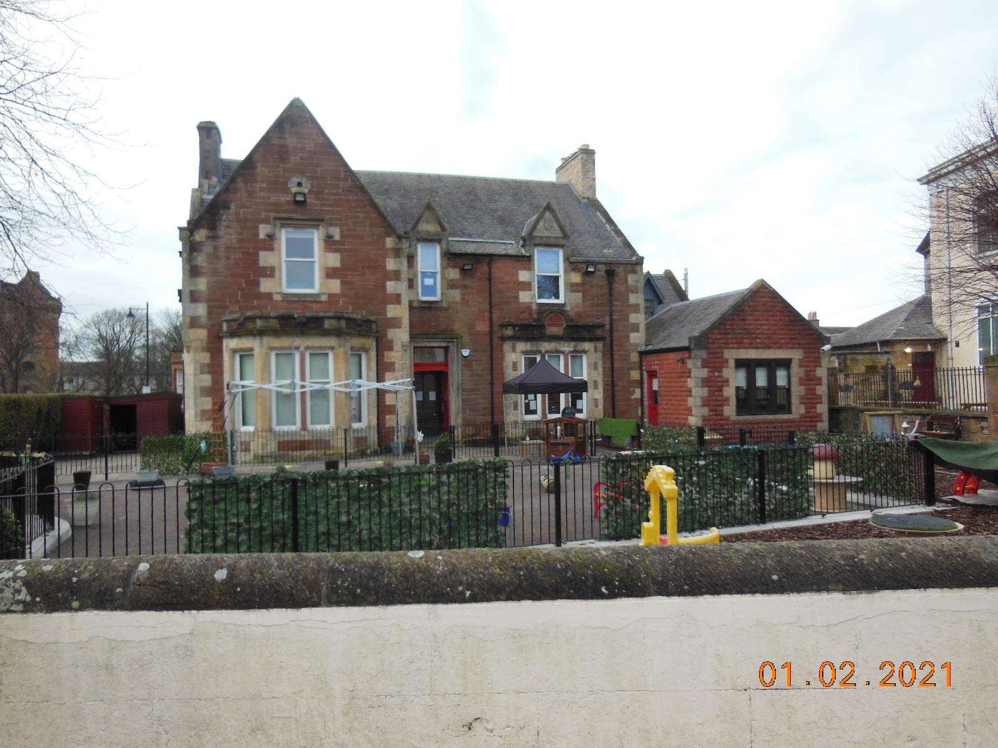
Introduction

Riverbank is a privately owned nursery caring for children aged 3 months to 10 years. We believe learning is individual to each child’s needs, abilities and interests and parents work collaboratively with staff in celebrating children’s achievements, strengths and in agreeing goals for learning and development. This supports each child to realise their full potential and become successful learners, confident individuals, effective contributors, and responsible citizens.

Riverbank continues to maintain a strong family ethos, providing a home from home feel using the ‘Hygge’ approach. This is a Danish concept which promotes a nurturing and calm environment and slow pedagogy of being in the moment with the child. This does not retract from intentional learning which is important in promoting and treating every experience as an opportunity to learn.

The nursery is registered for 72 children daily, with 21 Practitioners, Cook, Depute, Manager and Owner. All staff are SSSC registered, ensuring a continuous cycle of reflection and review. Key staff have additional Leadership responsibilities which assist in professional development and improving outcomes for children. The wellbeing of our staff has been integral to promoting a nursery wide approach to good mental health and wellbeing.

Values

As part of our improvement for 2024-25, we began a consultation on our vision, values and aims to state clearly what we stand for, this included input from all involved in the life of the nursery. A shared vision which promotes children’s rights, fairness, and equality of opportunity. Our focus is on developing the uniqueness of every child by providing a loving, caring ethos where children are valued and listened to.
We continue to be ambitious and in line with local and national priorities. In addition to supporting children to be confident, healthy and happy, we aspire to put our values into practice daily.
Values

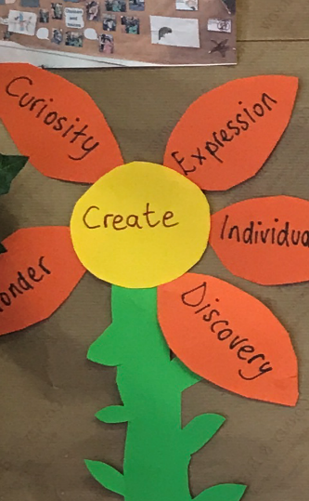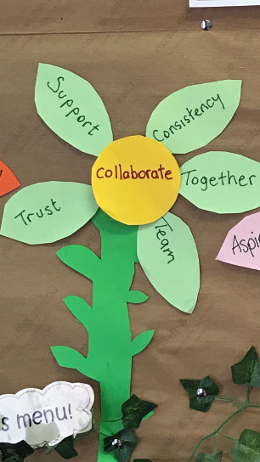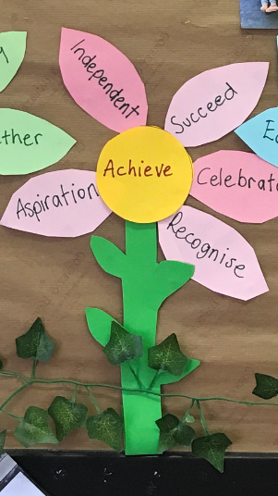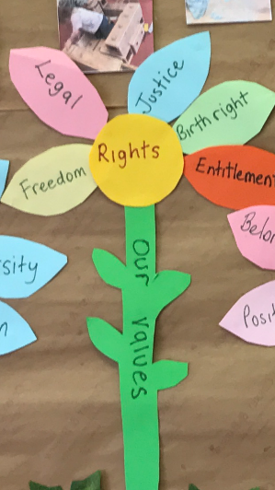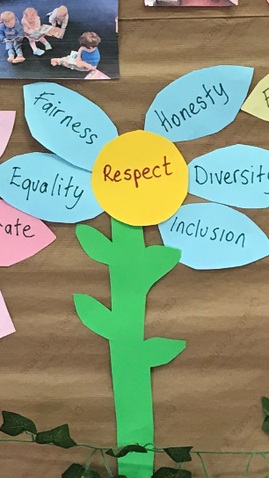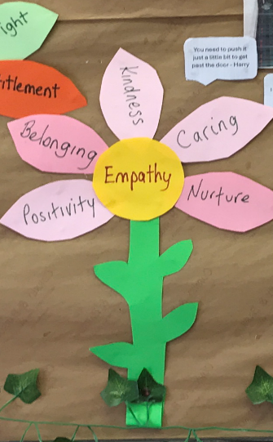

CREATE COLLABORATE ACHIEVE RIGHTS RESPECT EMPATHY
Current Aims are;

- To ensure that all individuals, regardless of their background, ability or differences, are valued and treated equally. Thus, creating an environment that welcomes and embraces diversity, where everyone feels valued, respected, and supported.
- To capture and enhance natural curiosity, building on the child’s potential for learning to nurture confident, capable and enthusiastic learners.
- To promote a culture of continuous professional development, creating an environment where learning is valued and supported every day.
- To promote effective partnership working with parents, children, staff and other agencies to support and improve outcomes for children.

Context of the early years centre

Riverbank Nursery is situated in the heart of Ayr and has been established since 1989. It’s open from 8am until 6pm Monday to Friday, 50 weeks of the year. We are in partnership with the local authority, which means that although we are a private nursery, we provide funded early learning and childcare on a part time, full year or term time basis for eligible children.

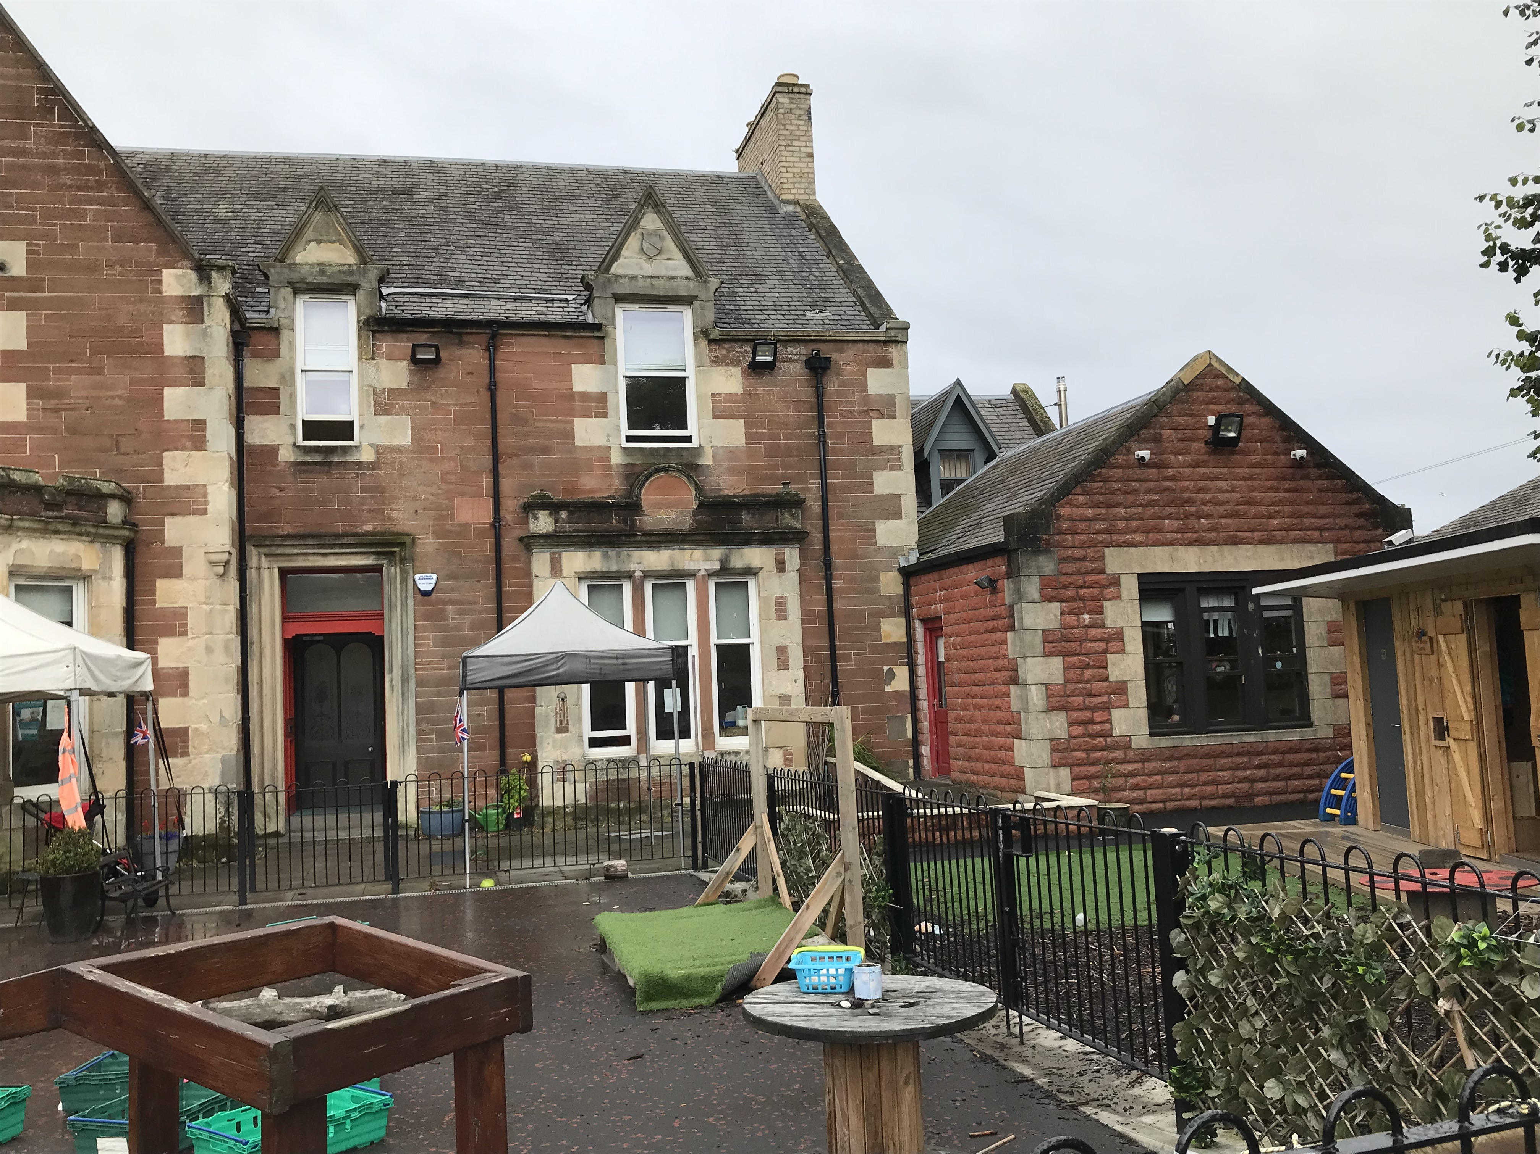
The Nursery building is set over two floors and comprises of eight spacious rooms, the ground floor accommodates our office, Bluebells, Buttercups, and Daisy rooms in addition to toilets and kitchen facilities. The upper floor plays host to our Juniors and Seniors along with children’s toilets and staffroom. Our outdoor space within the nursery grounds has been redeveloped as a large area for play and learning, promoting investigation and exploration through climbing, planting, cooking, digging, building, water and imaginative play. Our ‘Wellie castle’ provides storage for outdoor rain suits and wellies, aptly named by the children. It also a sheltered area for small group play, stories and songs, providing outdoor handwashing and toilet facilities. The indoor environment is also reviewed periodically to ensure it is responsive to the needs of the children, is stimulating, creative, exciting, and inspiring.

Out with the nursery, our children also utilise the grounds of St John’s Tower and the Fort Tennis Courts which are both only a few minutes’ walk from the nursery. As we have a central location, we benefit from walks to explore our local environment including the beach, river, train station and many more on a regular basis. Our ‘Teach on the beach’ programme supports our Eco Green Flag plan in learning about ocean pollution and climate change. We aim to continue to develop these experiences further in 2025-26.
As we are based in a central location for working parents our children are from all Scottish Index of Multiple Deprivation (SIMD) areas. Many children attending Riverbank are from parents in employment, resulting in part time placements with a few attending full time. The percentage of SIMD deciles are detailed as follows;

26% of our children are from deciles 1-3 | 43% of children are from decile 4-7 | 31% are in decile 8-10

We foster close links with our associated primary schools to ensure that children are confident in making the transition from nursery to primary education. Local schools have sent representative teachers to Riverbank to meet the children and discuss with keyworkers, transition arrangements within their school.

The following information was obtained in May 2025 and is recognised as the percentage of achieving 10 milestones as detailed below;-
 | 2020/21 | 2021/22 | 2022-23 | 2023-24 | 2024-25
Health and wellbeing | 75% | 95% | 93% | 100% | 97%
Communication and language | 60% | 70% | 87% | 71% | 93%
Mathematics and numeracy | 65% | 60% | 88% | 79% | 77%

This session our attainment figures demonstrate that almost all children have made good progress in Health and wellbeing and Communication and Language skills. Although maths and numeracy has reduced this year, the deficit is based on areas where children found difficulty in using simple graphs and charts, positional language and recognising how many without having to count. Following a review, all staff attended training on Quality assurance – A framework to support curriculum for excellence in early years, which will continue to be used to support staff to ensure a clear understanding in making accurate and consistent judgements of children’s progress and achievements in learning. Collecting and using assessment information strategically is essential in securing the reliability and accuracy of judgements made by different practitioners.

In reviewing progress with How Good Is Our Early Learning and Childcare (HGIOELC) quality indicators, we assigned the following 2024-25 grades using the six-point scale: overall, we rate ourselves as good but note areas for improvement, especially in strategic work.

Quality indicator | Category | Theme | Current Grade | Improvement priorities for 2025-26
1.3 | Leadership of change | Developing a shared vision, values and aims | Good | Continue to embed VVA and build on these when making decisions regarding strengths and areas to improve.
2.3 | Learning, Teaching and assessment | Effective use of assessment | Good | Improve reliability of data more effectively to address gaps in attainment
3.1 | Ensuring wellbeing, equity and inclusion | Fulfilment of statutory duties | Good | A range of mentoring and professional development opportunities will improve staff knowledge and skills of statutory duties which impact on children and their families
3.2 | Securing children’s progress | Progress in communication and language, mathematics and health and wellbeing | Good | Monitor the effectiveness of planning and assessment, reducing inconsistencies in quality of observations

What key outcomes have we achieved?

After recent staff changes, curriculum training improved assessment and tracking, resulting in a more child-friendly way to record progress and greater child involvement through photos, drawings, and input. Floorbooks supported collaborative planning and boosted staff confidence. The environment encourages independence, problem-solving, and responsibility. Most children select activities and focus well, with a few needing support; almost all are developing social skills and friendships.

We reviewed our Improvement plan using HGIOELC reflective questions to identify strengths and areas for growth. While our systematic self-evaluation approach included everyone, managing it effectively has been challenging. In 2025-26, we aim to strengthen leadership roles and provide relevant training, improving staff skills, knowledge, and confidence. Reflecting on the impact of Children’s rights will help us better amplify the child’s voice across the nursery, enhancing our quality of provision.

Our pathways are not defined by age, but by meeting the learning needs and attainment of the individual child. It builds on our Hygge and curiosity approach which promotes cosiness, familiarity, comfort and contentment, providing the opportunity for personalised learning experiences, to explore and investigate with confidence. As part of our accreditation through the ‘hygge’ approach we continue to foster warm, nurturing relationships providing a secure, safe, stimulating and above all a happy, home from home environment where kindness and love is central in all interactions.

We introduced swimming lessons for some children, recognising swimming as a vital life skill beyond physical health. These lessons build patience, confidence, and competence in water, while offering a safe environment for guided play, instruction, and sensory learning. All children attending received their first level achievement award.

We provide opportunities for interdisciplinary learning through sustainability, global citizenship, climate action and food and the environment as part of our Eco school targets. Children participate in a variety of enterprising activities, such as fundraising for charitable organisations and engaging in community projects. For instance, Riverbank contributed to the 'Night Before Christmas Campaign,' encouraging parental involvement across the nursery. Additionally, an initiative aimed at reducing waste led to collaboration with Tesco to establish a 'Community Food Larder.' This project enabled children to assume responsibility, deepen their understanding of food waste, enhance their awareness of charitable endeavours, and develop technological skills by utilising a QR code. We continue to raise funds for Whiteleys retreat on a weekly basis and all children took part in Comic Relief events raising £674. All these events provided children with the time to think about and help others, talk about love and kindness, feel good about giving and promoting a culture of compassion, sharing and generosity. By talking about enterprise children learned essential life skills such as costs, problem solving, and in decision making in the world of work.

Priority 1 Developing a shared vision, values and aims
NIF Priority:- Placing the human rights of every child and young person at the centre of education | Links to HGIOELC QI:-  1.3 Leadership of change | Links to CI Quality Framework QI:-  3.1 Quality assurance and improvement

Progress and Impact
The vision was reviewed by all service users to clarify its direction and pace for improvement. The language was considered for user-friendliness and alignment with a child-centred approach. Senior staff facilitated activities where children brainstormed and voted on aspects, they deemed important. The process of reflecting on the VVA aimed to support collaboration, creativity, achievement, respect, the promotion of rights, and fostering empathy and kindness.

Practitioners were encouraged to consider a core set of beliefs demonstrating high expectations, with a focus on clarifying past and future objectives. Feedback indicated that the vision contributes to transparency and ongoing improvement. Key values were identified as significant and connected to suggestions from children and parents involved in the review. Collaboration with parents helped establish consensus on the wording to support a shared vision for improvement and change.

All practitioners show a strong personal and collective commitment to our vision and to their professional values as outlined in professional codes of conduct and standards for registration with SSSC.

Training, research, and professional dialogue have increased staff confidence in leadership, collaboration, and innovation. All staff support ongoing improvement and change.

Through review we agree the VVA is what we aspire to do. These values are now being integrated into daily communications, interactions, and collaboration to guide decision-making

Next steps;
We will continue to embed and build upon our vision, values and aims, involving all when making decisions regarding strengths and areas to improve.

Priority 2 To improve our profiling and tracking procedures to lead to more robust assessment judgements.
NIF Priority:-  Closing the attainment gap between the most and least disadvantaged children and young people | Links to HGIOELC QI:-  2.2 Curriiculum  2.3 learning, teaching and assessment  3.1 Ensuring wellbeing, equality and inclusion | Links to CI Quality Framework  2.2 Children experience high quality facilities  1.1 Nurturing care and support  1.3 Play and learning.
Progress and Impact
Learning journal monitoring has been conducted by senior staff to review and moderate quality and judgment. A new template was implemented in October 2024 to align planning with milestone progression, and evidence is recorded in individual journals and floor books. This process has allowed for the identification of strengths in literacy and mathematics provision and has supported practitioners who require additional time to complete milestone data and develop professional judgment in assessment. Practitioners are using the new learning journals to involve children in reflecting on their own learning. Parents receive regular updates on their children's progress and achievements through care plan and learning journal meetings, including
information about transition progress.

During this session, staff undertook leadership roles in Literacy, Numeracy, Outdoor, Nurture, and Language and Communication, resulting in changes within the playrooms. The intention is to continue offering training opportunities to further enhance staff knowledge and skills in these areas.

Quality assurance processes provide an opportunity to moderate and feedback to staff to ensure that these are of a high quality and impacting on learning for the children. Almost all staff have reported that they found this helpful in their planning.

Improvements in observations (made since training with staff) now document the significant learning which has taken place for individual children. Focus on ensuring that observations of learning link to both intentional and responsive planning and are used as evidence when completing tracking.

With teacher support, some children faced extra planned challenges while others received specific help. All showed progress, tracked through assessment data that informed goal setting in Literacy, Numeracy, and Health and Wellbeing. Staff now consistently use updated planning formats to document child-led activities. Ongoing meetings with the SAC teacher provides support for staff in planning, assessment, transition reports and identifying next steps.

Next Steps
Use the ‘See, hear, feel’ form to regularly monitor playroom practice and provide feedback to staff individually or in meetings. Continue involving staff, children, parents, partners, and the community in self-evaluation to drive improvement and build staff capacity.

Priority 3 Progress in communication, early language, mathematics and wellbeing
NIF Priority:-  Closing the improvement gap between the most and least disadvantage children | Links to HGIOELC QI:-  2.2 Curriiculum  3.1 Ensuring wellbeing, equality and inclusion  2.4 Personalised support | Links to CI Quality Framework  2.2 Children’s experience high quality facilities  3.3 Leadership and management of staff and resources  4.1 Staff skills and knowledge
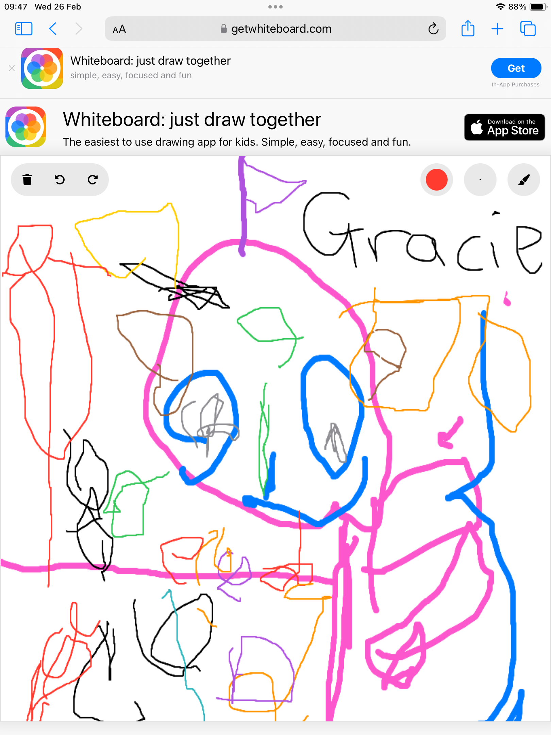
Progress and Impact
A quality assurance calendar was implemented to establish a self-evaluation system involving all staff, specifying dates to support interdisciplinary learning, curriculum development and significant events. This approach provided practitioners with clear information at the beginning of the academic year regarding expectations for planning, assessment, and parental involvement. New planning formats were introduced, supporting child-led responsive planning in alignment with either Curriculum for Excellence for children aged 3-5, or Realising the Ambition for those under 3 years old.

We have expanded the numeracy and mathematics area within the indoor environment in response to its popularity and increased space requirements. Despite two staff members participating in mathematics training, the anticipated positive impact has not yet been realised. Additional support is necessary to ensure that the knowledge and skills acquired are effectively implemented, ultimately improving outcomes for children.

Responsive planning involves integrating children's interests into activities by observing their cues and adapting learning opportunities accordingly. Practitioners continually assess and adjust the environment and resources to ensure flexible, inclusive use.

Initiatives included creating language-rich spaces, reducing noise, and consulting a Teacher of the Deaf for listening support. Children contributed to designing creative learning areas, which improved wellbeing, communication, and maths. Activities such as 'Big I wonder questions' promoted problem solving, while daily routines strengthened phonics, rhyme, alliteration, and syllable skills.

Our outdoor area is continually developing and being adapted in line with guidance, effects of weather, safety and the passion and commitment of our Outdoor Champions and staff team. They have taken the lead and have put together an action plan in line with current pedagogy, curriculum guidance, such as out to play, my world outdoors and space to grow. However, this has not been without challenge, as the adverse weather continues to have an effect on the quality of learning in our nature/biodiversity garden, making some of the areas unsafe for children to access during such times. Practitioners remain solution focused at all times and continue to ensure children have quality outdoor experiences regardless of the challenges faced.
This year our Eco lead and outdoor play champion have continued to work together to create a planting and growing areas, which has been successful in providing opportunities to harvest and cook vegetables and fruit for children to cook, taste and eat.

Next steps:
Enhance staff pedagogy for outdoor learning opportunities.
Strengthen staff understanding of maths learning stages to better scaffold children's numeracy development.

Evaluation Summary
Quality Indicator | Self Evaluation  (Please add 3 or 4 evaluative statements linked to the themes)
1.3  Leadership of change  Developing a shared vision, values and aims relevant to the ELC and its community  Strategic planning for continuous improvement  Implementing improvement and change | As a team, we are identifying our strengths through observation, moderation, training, self-evaluation, and analysis of assessment data.  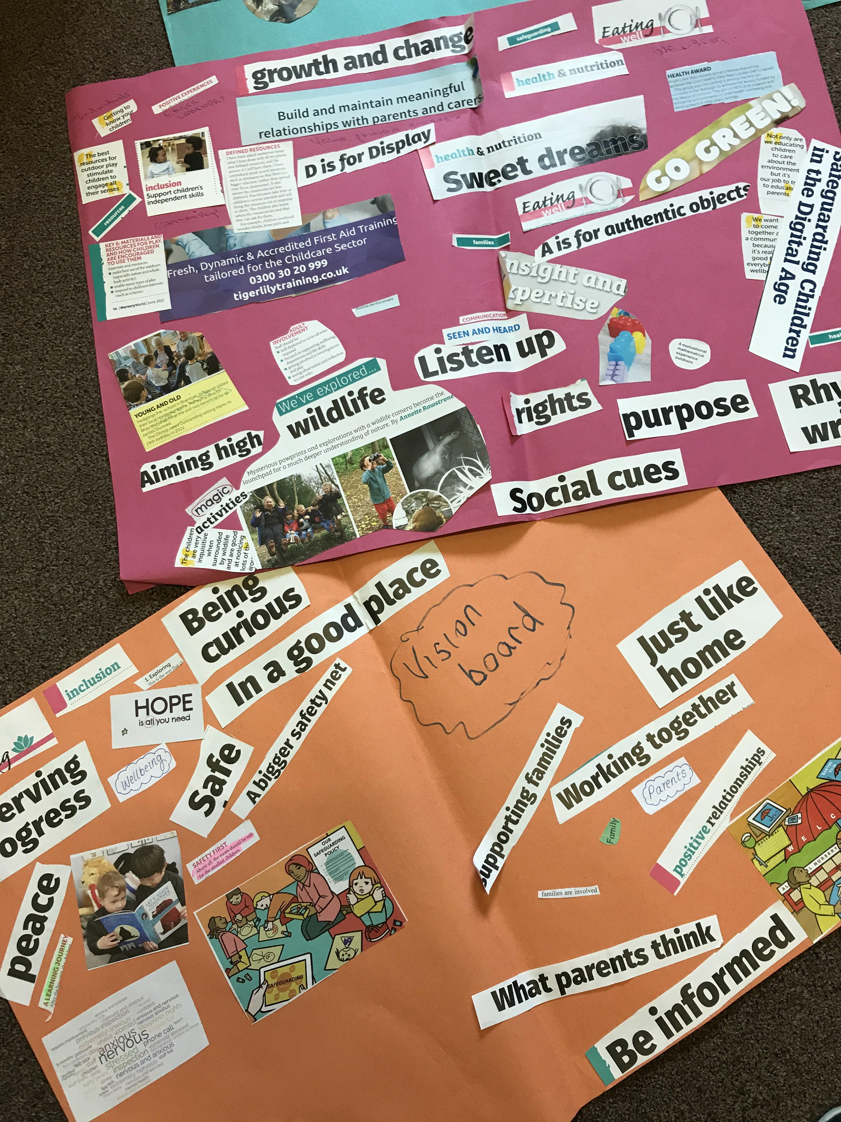  Moderation is used to identify areas for development by applying research and established methods to support learning, play, and interaction.  Collaboration was undertaken with both school and college students; as children participated in ‘Stay and Play’ sessions at Ayr College and engaged in art and dance activities facilitated by the Gaiety Team.  Maintaining strong partnerships with families continues to be a priority to effectively address children's needs, with regular opportunities for parental involvement provided throughout the year.  We are proud to have completed our annual Sun Safe Nurseries Accreditation. The accreditation programme has been developed by national melanoma and skin cancer charity ‘Skcin’ to assist us in our duty of care to safeguard children against the dangers of Ultraviolet Radiation (UVR) and educate parents and children on the importance of sun safety to influence behaviours.  Our policy has been reviewed, and parents have been informed of the link to the charity for further support and guidance. This has improved the number of children with sun hats and an understanding of staying safe in the sun.  Stay and play sessions were also promoted and Book bug sessions are always very popular as we learn new songs and listen to stories, we also use puppets while interacting with the song box and materials. We have re-introduced home learning bags and Daisy Duck adventures with a diary to record all the exciting places visited with families. Parents can talk openly to practitioners and management which assists in bringing peace of mind that their child is cared for and supported throughout the day. There are a number of ways we engage and involve parents in the life of the nursery including an updated information booklet, communication diaries, all about me, learning journals, care plans, newsletters, notice board, photographs, special events, questionnaires and surveys and discussions initiated during drop off and pick up times. Parents know their children best, as practitioners liaise with them to identify children’s starting points and possible gaps that their child may need support in.  Carpets have been replaced and the playrooms have been repainted and decorated and now appear lighter, more organised, inviting, and homely.  Next steps  As staff take on leadership roles, they are increasingly evaluating how practices and the environment affect children.
2.3 Learning, Teaching and Assessment  Learning and engagement  Quality of interactions  Effective use of assessment  Planning, tracking and monitoring | An intergenerational project allowed children to visit a local care home, where they interact with residents through activities like craft making, dance, songs, and rhymes. Most children participate actively, sharing ideas and asking questions.  Practitioners incorporate children’s feedback to refine nursery routines, planning, snack provision and events. Lunchtimes are conducted in a calm atmosphere with soft music, where children confidently serve themselves. Staff demonstrate a sound knowledge of each child and respond sensitively, adjusting their approaches as necessary. This has impacted on children’s self-regulation and emotional wellbeing.  We are beginning to streamline our documentation to ensure consistency of policy and clarity around planning, tracking and monitoring, while also implementing new developments from South Ayrshire Education support - Teacher input and Quality assurance visits.  Current planning practices are tailored to support each child's development, taking into account both age and ability. Systematic data collection facilitates the identification of children who may require additional support or greater challenges.  Children are actively involved in planning and making decisions regarding their learning. Integrating intentional planning with reflective practice has led to enhanced engagement, increased motivation, and a deeper understanding of content.  Assessment has become more practical for staff as time is set aside specifically for professional  discussions. In addition, all staff members have access to relevant and reliable data to support this process.  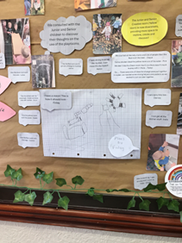  After a children's planning meeting, participants undertook tasks related to designing and rearranging areas, rooms, and resources. One child created architectural plans, some children formed the removal team, while others acted as leaders by reading the drawings and directing where furniture should be placed. This process provided an opportunity for children to participate in shaping their learning environment, collaborate, and understand individual responsibilities during the changes. The activity was later evaluated, encouraging all children to participate, expanding options for play, increasing engagement, and supporting access to various resources within different areas.  Next steps  To improve our indoor and outdoor environment in promoting literacy and numeracy teaching and learning.  Enhance children’s learning journals for consistent observation content and effective use of next steps to support milestone assessment and accelerate progress.
3.1 Ensuring wellbeing, equity and inclusion  Wellbeing  Fulfilment of statutory duties  Inclusion and equality | Staff report greater knowledge and understanding of ways to support children with identifying and regulating their emotions. Children are confidently using emotions visuals and the colour Monster puppets..  The child's voice is a fundamental element of our nursery's daily operations. Staff members are committed to ensuring that all children's perspectives and opinions are respected and valued. Learning experiences are documented through floor books, capturing each child’s input and reflecting the knowledge and skills acquired.  We introduced individualised support to help children talk about their emotions due to increased distressed behaviour which led to reaction rather than response. Further development, reflection and co-regulation led to a focus on emotions and not on behaviour.  Using the data gathered, we are beginning to identify gaps, change and opportunities missed. In doing so we ensured staff have a clear understanding of their roles and responsibilities in supporting children’s learning and wellbeing. Modelling, coaching, training and development ensure they have the skills and knowledge required. This is evidenced within our Training Matrix.  We use the Scottish Index of Multiple Deprivation to identify and monitor children from disadvantaged backgrounds. As a central nursery serving all SIMD deciles, we provide targeted interventions and support based on individual needs. We recognise that children from any SIMD area may face unique challenges, so we assess each child’s circumstances when planning support. To improve this, we are enhancing our use of Ferre Laevers observations for more effective support, both in the 3-5 room and during transitions from the 2-3 room.  The Early Learning and Childcare National Induction Resource has been used to assist new staff to understand and build knowledge of their role in ensuring a quality service for children and families. As we have had some staff resign, a review of our exit strategy has prompted discussions with staff on how we manage the transition process for all.
3.2 Securing children’s progress  Progress in communication, early language, mathematics, health and wellbeing  Children’s progress over time  Overall quality of children’s achievement  Ensuring equity for all children | The Education approach places the rights and needs of all children and young people at the centre. A staff member is designated as a 'Rights defender' who works to ensure children's rights are prioritised in planning and improvement processes. This individual has relevant expertise and supports the commitment to initiatives such as 'keeping the Promise'.  Healthy choices are discussed, and children help develop lunch routines using the Setting the Table document. They self-serve, register for meals, and assist in cleaning up afterward. Practitioners join children at the tables to support routines, monitor allergies, and encourage social interaction.  Staff have enhanced the outdoor environment to support children's learning about nature. Children have grown various vegetables, which they harvest, cook, and taste, increasing their enthusiasm and  engagement outdoors. These activities have also sparked conversations about healthy choices and helped children understand food origins.  We have improved the environment for children to support their progress across the curriculum. Regular environmental audits helped staff identify strengths and areas for development, resulting in more engaging and well-resourced rooms that encourage curiosity. Staff have enhanced play provocations and shared ideas at planning meetings, increasing children's engagement in various areas. Loose parts now enrich play both indoors and outdoors.  Quality assurance ensures staff moderation and feedback, supports high standards in children’s learning. New care plans and learning journals celebrate achievements and successes alongside parents or carers. Milestone assessments and a termly attainment database provide a clear overview of progress and help identify children needing extra support.  To ensure GIRFEC and equity, we work in partnership with a range of agencies including ‘Teacher of the deaf’, NHS toothbrushing, Speech and language and the Education support team.  Assessments show all children moving to primary one meet developmental milestones, with some exceeding expectations in number and language skills; these children receive additional challenge. Learning activities are planned to balance support and challenge, guided by staff input and adult-led focuses. This approach ensures full curriculum coverage and addresses next learning steps. Planning references the UNCRC, and each child has a care plan reviewed quarterly with parents or carers. Achievements beyond nursery are celebrated with peers, and children's feedback informs planning and assessment.

What are the key priorities for improvement in 2025/26

Our Improvement Plan takes account of local priorities alongside those in the National Improvement Framework (NIF).

Further develop rights-based pedagogy to promote equality, equity, and inclusion

Reflect on the impact of ‘spaces, experiences and interactions’ in extending children’s learning indoors and outside to improve outcomes.

Further develop self-evaluation and quality assurance to improve and sustain positive outcomes for children and families

What is the capacity for improvement?

With staffing levels stabilised, efforts have been redirected towards systematically evaluating the quality of provision by reviewing both strengths and areas for improvement. A variety of data sources are used to guide these developments, with input from colleagues, families, professionals, and local authorities to support effective outcomes for children. The team maintains consistent standards of care and education, accompanied by ongoing professional development.

To enhance our service delivery, we reviewed strategies for deepening our understanding of the new Quality Framework, with a particular emphasis on integrating children's rights. Additionally, we identified opportunities to provide further training to advance staff skills and knowledge.

The nursery will maintain an environment that supports inclusion. The learning approach recognises variations in children's experiences, interests, and backgrounds and aims to provide equal opportunities for all.

This Standards and Quality Report and Improvement plan will be published on our website, promoted within the nursery and displayed as part of our journey to improvement

